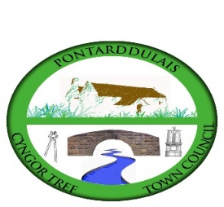
CYNGOR TREF PONTARDDULAIS TOWN COUNCIL

Councillor Co-option Application

NAME:
ADDRESS:
EMAIL:
CONTACT NUMBER:

Why do you wish to become a town councillor?
What are the main areas in Pontarddulais you would like to see improved?
What experience do you feel you can bring to the council?
Please return to: | Hilary Davies  Clerk to Pontarddulais Town Council
45 St Teilo Street
Pontarddulais
Swansea SA4 8SY

Email: | clerk@pontarddulaistowncouncil.gov.uk
Telephone: | 07939 592168
CLOSING DATE FOR APPLICATIONS: 17 NOVEMBER 2023

