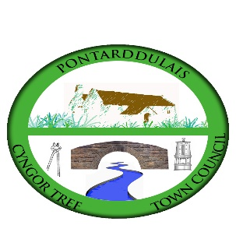

CYNGOR TREF PONTARDDULAIS TOWN COUNCIL

APPLICATION FOR FINANCIAL ASSISTANCE (MAX AWARD £250)

- Name of Group:

Address:

Telephone:

E-mail:

Contact name:

- Please provide a summary of your organisation’s objectives and core activities (max 50 words):

- What would your organisation spend this money on? (max 100 words)

- How would this benefit the community in Pontarddulais? (max 100 words)

Signed:

Position:

Please return your completed application, along with a copy of your groups latest balance sheet (see Appendix 1) via email to: clerk@pontarddulaistowncouncil.gov.uk

Hard copies can be delivered to
Mrs Hilary Davies
Clerk to the Council
Cyngor Tref Pontarddulais Town Council
The Institute
45 St Teilo Street
Pontarddulais
SA4 8SY

Contact details for queries: Mobile: 07939 592168 / Office: 01792 883348

The closing date for applications is 5.00pm, 14 February 2024.
Please note no applications will be considered after the closing date.

If your application is successful the money will be transferred electronically into the groups bank account, therefore please supply the following bank details:

Name of account:

Sort code:

Account number:

APPENDIX 1

BALANCE SHEET (basic example)

£
Group Name:

Cash in hand:

Cash in bank:

Total Reserves:

Please contact the Clerk to the Council should we require help completing the balance sheet.

