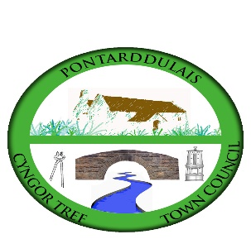

CYNGOR TREF PONTARDDULAIS TOWN COUNCIL

APPLICATION FOR FINANCIAL ASSISTANCE

- Name of Group:

Address:

Telephone:

E-mail:

Contact name:

- Please provide a summary of your organisation’s objectives and core activities (max 50 words):

£
- Please state the amount you are requesting:

- What would your organisation spend this money on? (max 100 words)

- How would this benefit the community in Pontarddulais? (max 100 words)

Signed: ____________________________________ Date: _____________

Position: ______________________________________________________

Please return your completed application form, along with a copy of your latest balance sheet to:

Aneurin John
Clerk to the Council
Cyngor Tref Pontarddulais Town Council
The Institute
45 St Teilo Street
Pontarddulais
SA4 8SY

Tel No’s Office: 01792 883348
Home: 01792 885890
Mobile: 07791160219
Email: pontarddulaistowncouncil@yahoo.co.uk

PLEASE NOTE THE CLOSING DATE FOR RECEIPT OF APPLICATIONS IS THE 16TH FEBRUARY. APPLICATIONS RECEIVED AFTER THIS DATE WILL NOT BE CONSIDERED.

IF YOU ARE SUCCESSFUL THE MONEY WILL BE TRANSFERRED ELECTRONICALLY INTO YOUR BANK. PLEASE SUPPLY THE FOLLOWING BANK DETAILS:

Name of account:

Sort code:

Account number:

