Reporting on Section 6
Community and Town Councils

Environment (Wales) Act 2016 Part 1 – Section 6
The Biodiversity and Resilience of Ecosystems Duty

The Biodiversity and Resilience of Ecosystems Duty
Report 2025
Name of Community or Town Council: | Pontarddulais Town Council
Group: | 2
Introduction and Context
- A short description of the Council, its functions and context in relation to
- how it could help biodiversity (through functions with regard to land management, grant funding, education activities, for example)
- spatial scale and place (e.g. how much land does it cover, population, precept?)
- public service delivery (e.g. is it subject to the Well-being of Future Generations (WFG) Act?)
The Council owns, occupies and manages the Mechanics Institute building on St Teilo Street in Pontarddulais. It is a three-storey building with a hall and stage for events as well as rooms for hire to local organisations to improve the facilities and amenities for Pontarddulais.
The Council could help biodiversity by reducing the carbon footprint of running the building. Managing the land it owns/has responsibilities for more sustainably and providing opportunities for community education and engagement around biodiversity.
The Council does not own any parks or play areas but does own land around the cenotaph, including flower beds, green space and planters. The Council also has responsibility for footpath maintenance in the area.
The Council comprises 16 members over 5 community wards, has one full-time and three part-time members of staff. The population of Pontarddulais was approx 6200 at the last census and the precept for 2025/26 is £174,000.

Action Report 2023 - 2025
NRAP  Objective | Action carried out to… |  | Monitored by:
1 | -embed biodiversity into decision making & procurement | The Estates committee has been given a new focus which includes the Environment, forming a new Estates and Environment Committee. The Town Clerk has skills gained from another Council which she uses to improve the decision-making and procurement at Pontarddulais. The urinals in the toilets were on a flush cycle every couple of minutes with an enormous water cost. A Cisterniser has been fitted to the system which has drastically reduced the water use for the building but it is too recent to have exact figures. | Town Clerk and Council
1 | -raise awareness of biodiversity & its importance | The Council has started to engage with the community on environmental matters. Having secured a LPfN Bulb package, the Council has worked with community volunteers to plant native spring bulbs into areas not previously planted. | Town Clerk and Council
2 | -safeguard principal species and habitats | The Council has realised that this has not been routinely considered in previous years and has started work in this area by planting 200 native spring bulbs and considering habitat improvement rather than just maintenance of flower beds. | Town Clerk and Council
3 | -restore & create habitats and resilient ecological networks | The Estates and Environment committee now considers ways the Council can work to improve the management of open spaces it’s responsible for, native planting and management/removal of invasive species is a major consideration and this work is planned to expand to provide wildlife havens within the urban landscape. | Town Clerk and Council
4 | -tackle negative factors: for e.g. reduce pollution, use nature based solutions, address invasive species | The Council is removing invasive species from areas which they manage as carefully as possible to avoid contamination of waterways and the potential of seeding areas further downstream. The contractor responsible for footpath and ground maintenance understands the importance of this management. | Town Clerk and Council
5 | -use improve and share evidence | Had a visit from the OVW LPfN officer to provide insight and evidence of ways of working the Council was currently undertaking which could be negative or neutral to biodiversity. This report was shared with all Councillors to improve their understanding. Councillors who are members of the Estates and Environment Committee have been encouraged to undertake the OVW biodiversity training modules. Some have already achieved this. The Council budgets for annual floral displays from Swansea Council every year. The LPfN Officer highlighted the lack of improvement in biodiversity despite a significant spending commitment. The Council will need to increase engagement to raise awareness, understanding and commitment to alternative ways of making the Town welcoming during the growing months. | Town Clerk and Council
6 | -support capacity and/or other organisations | The Estates and Environment Committee has been created to shine a light on sustainability and biodiversity. The Council will consider including a budget for environmental projects for 2026/27 and going forwards. The Council provides a small grant scheme for community organisations, environmental projects has been added to the criteria. | Town Clerk and Council

Review of S6 duty actions for 2023-2025
What has worked well? | Creation of the Estates and Environment Committee  Visit by OVW LPfN Officer  Reduction in water usage.
What have the barriers been? | Lack of understanding from members and previous staff of the Section 6 duty.
What will you change? | Improve areas where we currently have responsibility to include more native species. Create biodiverse spaces and safe habitats for pollinators. Increase understanding among staff and members and external contractors and engage more with the community to educate them help them to understand why town may start to look different to what they’re used to.  Green energy supply will be sought at end of current contract. Light fittings in the building will be changed to LED to reduce our carbon footprint. The Council’s banking arrangements will be reviewed with sustainability front and centre.  The Council’s heating system needs efficiencies to be made.
How and when will the s6 duty be monitored and the s6 plan reviewed? | The S6 duty will be monitored 6 and the plan reviewed 6 monthly.

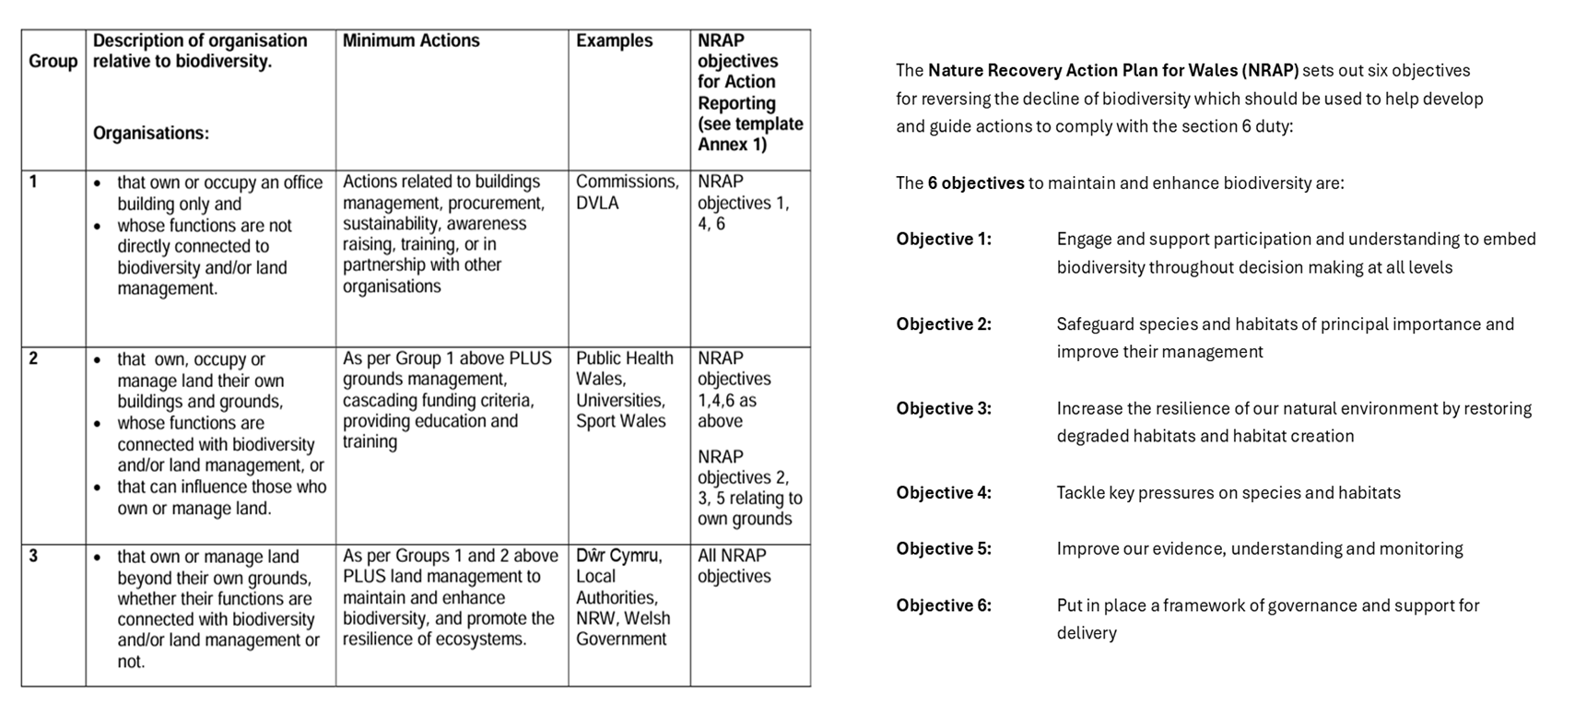
Back

Adrodd ar Adran 6
Cynghorau Tref a Chynghorau Cymuned

Deddf yr Amgylchedd (Cymru) 2016 Rhan 1 – Adran 6
Y Ddyletswydd Bioamrywiaeth a Chydnerthedd Ecosystemau

Adroddiad 2025
Ddyletswydd Bioamrywiaeth a Chydnerthedd Ecosystemau

Enw y Cyngor Tref neu Gymuned:
Grŵp:
Cyflwyniad a'r Cyd-destun
- Disgrifiad byr o'r Cyngor, ei swyddogaethau a'r cyd-destun o ran
- sut y gallai helpu bioamrywiaeth (trwy ei swyddogaethau rheoli tir, cyllid grant, gweithgareddau addysgol e.e.)

- graddfa ofodol a lle (e.e. faint o dir mae'n ei gynnwys, poblogaeth, praesept?)

- cyflawni gwasanaethau i'r cyhoedd (e.e. a yw'n destun Ddeddf Llesiant Cenedlaethau'r Dyfodol?)

Adroddiad Gweithredu 2023 - 2025
Amcan NRAP | Camau gweithredu i... |  | Wedi eu monitro gan:
1 | -cynnwys bioamrywiaeth o fewn llunio penderfyniadau a chaffael
1 | -codi ymwybyddiaeth o fioamrywiaeth a'i bwysigrwydd
2 | -diogelu prif rywogaethau a chynefinoedd
3 | -adfer & chreu cynefinoedd a rhwydweithiau ecolegol cydnerth
4 | -mynd i'r afael ag elfennau negyddol: lleihau llygredd e.e. defnyddio atebion yn seiliedig ar natur, mynd i'r afael â rhywogaethau goresgynnol
5 | -defnyddio gwella a rhannu tystiolaeth
6 | -cefnogi capasiti ac/neu sefydliadau eraill

Arolwg o ddyletswydd Adran 6 2023 - 2025
Beth sydd wedi gweithio'n dda?

Beth fu'r rhwystrau?
Beth fyddwch yn ei newid?
Sut a phryd fydd y ddyletswydd Adran 6 yn cael ei monitro a'r cynllun Adran 6 wedi'i adolygu?

Nôl
