Clerc: P.A. John
45 Stryd Sant Teilo
Pontarddulais
ABERTAWE
SA4 8SY

Rhif ffôn: (01792) 883348
Rhif ffôn: (01792) 885890
Ffôn symudol: 07791160219

Clerk: P.A. John
45 St Teilo Street
Pontarddulais
SWANSEA
SA4 8SY

Tel No: (01792) 883348
Tel No: (01792) 885890
Mobile: 07791160219

CYNGOR TREF PONTARDDULAIS TOWN COUNCIL
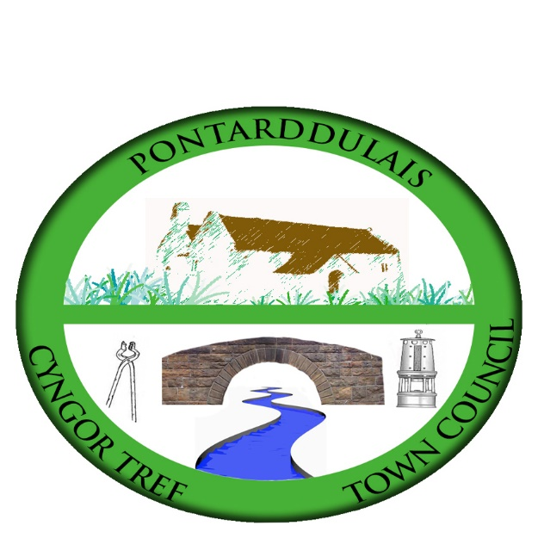

Email/Ebost: clerk@pontarddulaistowncouncil.gov.uk
Website/Gwefan: www.pontarddulaistowncouncil.gov.uk

Correspondence is welcomed in English or Welsh / Croesewir gohebiaeth yn Gymraeg neu’n Saesneg

06 May 2022

YOU ARE HEREBY SUMMONED TO ATTEND THE ANNUAL MEETING OF PONTARDDULAIS TOWN COUNCIL TO BE HELD ON THE 12^{h} DAY OF MAY 2022 COMMENCING AT 7.00PM FOR THE PURPOSE OF TRANSACTING THE FOLLOWING BUSINESS (REMOTE ACCESS)

P. A. John
Clerk to the Council

BUSINESS

Fifteen minutes prior to commencement of business members of the public will be invited to ask questions

1. Apologies for absence.

2. To receive declarations of personal interest from Members in accordance with the Council's Code of Conduct.

3. Election of Mayor.

4. To receive the Mayor's Declaration of Acceptance of Office.

5. Election of Deputy Mayor.

6. To receive Declarations of Acceptance of Office from all Councillors.

7. To fix the amount of the Mayor's Allowance in pursuant of Section 34(5) of the Local Government Act 1972.

8. To appoint Members to serve on the undermentioned committees:

- Policy & Resources (formerly Finance Committee);
- Estates, Development & Regeneration;
- Special Events;
- Welsh Language Working Group.

9. To appoint two representatives to serve on the following bodies:

- Swansea Area Committee of One Voice Wales;
- Larger Councils Committee of One Voice Wales.

10. To fix the dates of the ordinary meetings of the Council for the ensuing year.

11. To receive and consider the minutes of the Council meeting held on the 7th April 2022 (attached).

12. To receive and consider the minutes of the Special Events Committee meetings held on the 27th April 2022, 4th May 2022 and 10th May 2022 (attached).

13. To receive and consider reports from County Ward Members.

14. To receive and consider any urgent matters from Town Councillors.

15. To answer questions from Councillors (3 clear days’ notice of any question having been given to the person to whom it is addressed.

16. To receive and consider reports from the Clerk

17. To receive and consider reports from the Grants Officer.

18. To receive and consider reports from the outgoing Mayor.

19. To receive and consider reports from representatives on outside bodies.

20. To consider and determine applications received for the five casual vacancies on the Council (information attached).

21. To consider and determine applications for financial assistance towards various Jubilee celebration activities (information attached).

22. To consider the role of Canolfan y Bont in relationship with Pontarddulais Town Council, Swansea City Council and the Labour Party as a whole (agenda request from Cllr R. John).

23. To authorise and approve the expenditure for the month of April 2022.

24. To receive a monthly income report and bank reconciliation for the month of April 2022.

25. To receive planning applications previously circulated to all councillors.

