Clerc: P.A. John
45 Stryd Sant Teilo
Pontarddulais
ABERTAWE
SA4 8SY

Rhif ffôn: (01792) 885890
Rhif ffôn: (01792 883348)
Ffôn symudol: 07791160219

CYNGOR TREF PONTARDDULAIS TOWN COUNCIL
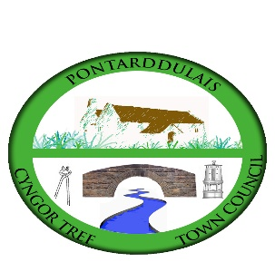
Clerk: P.A. John
45 St Teilo Street
Pontarddulais
SWANSEA
SA4 8SY

Tel No: (01792) 885890
Tel No: (01792) 883348
Mobile: 07791160219

Email/Ebost: clerk@pontarddulaistowncouncil.gov.uk
Website: www.pontarddulaistowncouncil.gov.uk

Correspondence is welcomed in English or Welsh / Croesewir gohebiaeth yn Gymraeg neu’n Saesneg
30 September 2022

A MEETING OF PONTARDDULAIS TOWN COUNCIL WILL BE HELD IN THE INSTITUTE, PONTARDDULAIS ON THURSDAY 6th OCTOBER 2022 AT 7.00PM

P. A. John
Clerk to the Council

15 minutes prior to the meeting members of the public will be allowed to ask questions. BUSINESS

  - Apologies for absence.

  - To receive declarations of personal and/or prejudicial interest from Members in accordance with the Council’s Code of Conduct.

  - To receive an address from Mr Joseph Barry, Local Area Co-ordinator.

  - To receive and consider the minutes of the Council meeting held on the 1st September 2022 (copy attached).

  - To receive and consider the minutes of the Special Events Committee meeting held on the 27th September 2022 (copy attached).

  - To receive and consider the minutes of the Policy & Resourced Committee meeting held on the 29th September 2022 (copy attached).

  - To receive reports from County Ward Members.

  - To receive and consider any urgent matters from town councillors.

  - To answer questions from Councillors (3 clear days’ notice of any question
having been given to the person to whom it is addressed).

  - To receive and consider reports from the Clerk.

  - To receive and consider reports from the Mayor.

  - To receive an update on the complaint received concerning the hire of the Institute.

  - To reconsider the composition of the Working Group investigating the proposed development North of Pontarddulais.

  - To consider the request from Pontarddulais Partnership for financial assistance towards their “warm space and a complimentary bowl of soup” scheme (email sent to all Councillors on the 16th September.

  - To receive and consider reports from representatives on outside bodies.

  - To authorised and approve the expenditure for the month of September 2022 (copy to follow).

  - To receive a monthly income report and bank reconciliation for the month of September 2022 (copy to follow)

  - To receive planning applications previously circulated to all Members (copy to follow).

