Clerc: H. J. Davies

45 Stryd Sant Teilo

Pontarddulais

ABERTAWE

SA4 8SY

Rhif ffôn: (01792) 883348

Ffôn symudol: 07969 050759

Clerk: H. J. Davies

45 St Teilo Street

Pontardulais

SWANSEA

SA4 8SY

Tel No: (01792) 883348

Mobile: 07969 050759

**CYNGOR TREF PONTARDDULAIS TOWN COUNCIL**

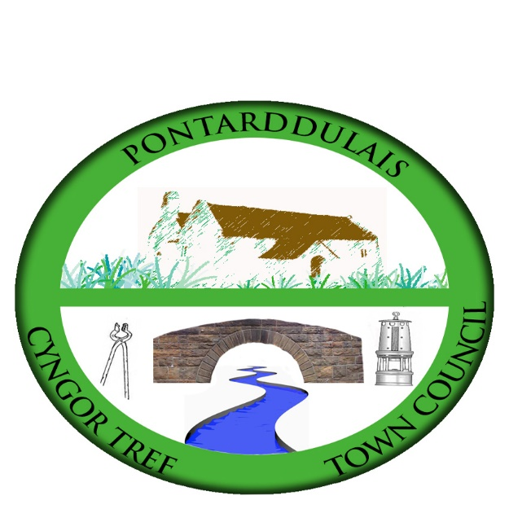

Email/Ebost: [hilary.davies@pontarddulaistowncouncil.gov.uk](mailto:hilary.davies@pontarddulaistowncouncil.gov.uk)

Website/Gwefan: www.pontarddulaistowncouncil.gov.uk

*Correspondence is welcomed in English or Welsh / Croesewir gohebiaeth yn Gymraeg neu’n Saesneg*



15 January 2023

**A MEETING OF THE POLICY AND RESOURCES COMMITTEE WILL BE HELD IN THE INSTITUTE ON THURSDAY 19th JANUARY 2023 AT 6.00PM**

*H. J. Davies -* Clerk to the Council

**BUSINESS**

1. Apologies for absence.

2. To receive declarations of personal interest from Members in accordance with the Council's Code of Conduct.

3. To agree minutes of last meeting:

4. Pre-cept

5. Training plan

6. Finance & Governance Toolkit: next steps

7. Committees’ Terms of References

8. Purchases

9. Policies