Clerc: H. J. Davies

45 Stryd Sant Teilo

Pontarddulais

ABERTAWE

SA4 8SY

Rhif ffôn: (01792) 883348

Ffôn symudol: 07969 050759

Clerk: H. J. Davies

45 St Teilo Street

Pontardulais

SWANSEA

SA4 8SY

Tel No: (01792) 883348

Mobile: 07969 050759

**CYNGOR TREF PONTARDDULAIS TOWN COUNCIL**

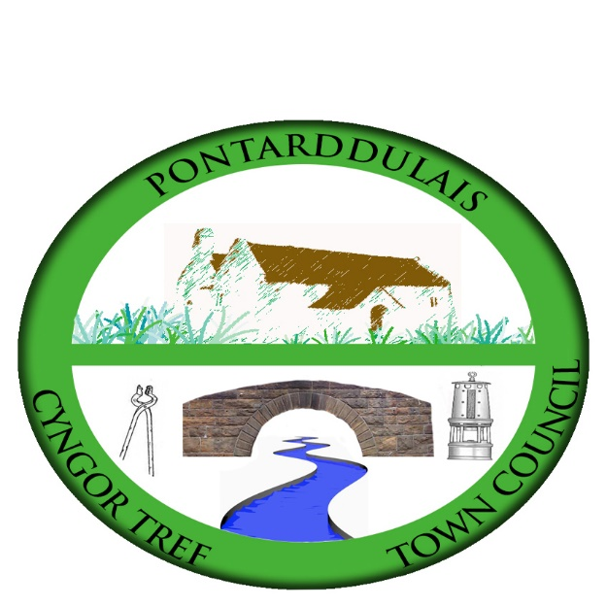

Email/Ebost: [hilary.davies@pontarddulaistowncouncil.gov.uk](mailto:hilary.davies@pontarddulaistowncouncil.gov.uk)

Website/Gwefan: www.pontarddulaistowncouncil.gov.uk

*Correspondence is welcomed in English or Welsh / Croesewir gohebiaeth yn Gymraeg neu’n Saesneg*



21st April 2023

**A MEETING OF THE POLICY AND RESOURCES COMMITTEE**

**ON WEDNESDAY 26TH APRIL 2023 AT 6:30PM**

**Meeting Room 1, Mechanics Institute**

*H. J. Davies -* Clerk to the Council

**BUSINESS**

1. Apologies for absence.
2. To receive declarations of personal interest from Members in accordance with the Council's Code of Conduct.
3. Minutes of last meeting for actions outstanding.
4. Training:
   1. Training records (to follow).
   2. Flick training
5. Budget Report
6. Income & Expenditure 2023-2024
7. Audit
8. Terms of Reference – all committees (copies to follow)
9. Matters arising from Estates Committee meeting on 20/4/23
   1. IT
10. Policies:
    1. Code of Conduct
    2. Civility & Respect Pledge
11. Personnel Matters
    1. Salary scales
    2. Pension
12. Matters referred from Council meeting on 6 April 2023:
    1. External Facilitator
    2. Dulais Square Christmas Tree
    3. 24-hour turnaround of minutes of meetings
13. Finance & Governance Toolkit:

* **Part 2: The self-assessment –** Vision, purpose and community planning