Clerc: H. J. Davies
45 Stryd Sant Teilo
Pontarddulais
ABERTAWE
SA4 8SY

Rhif ffôn: (01792) 883348
Ffôn symudol: 07969 050759

Clerk: H. J. Davies
45 St Teilo Street
Pontardulais
SWANSEA
SA4 8SY

Tel No: (01792) 883348
Mobile: 07969 050759

CYNGOR TREF PONTARDDULAIS TOWN COUNCIL
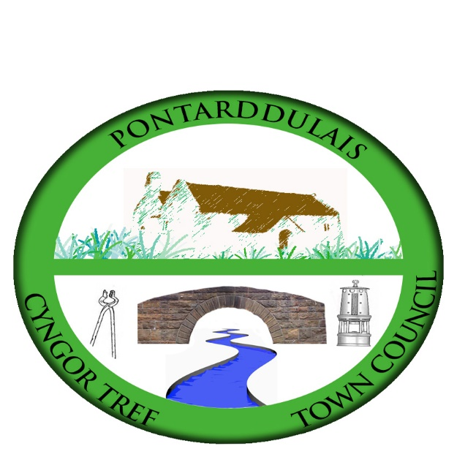

Email/Ebost: hilary.davies@pontarddulaistowncouncil.gov.uk
Website/Gwefan: www.pontarddulaistowncouncil.gov.uk

Correspondence is welcomed in English or Welsh / Croesewir gohebiaeth yn Gymraeg neu’n Saesneg

15 February 2023

A MEETING OF THE SPECIAL EVENTS COMMITTEE WILL BE HELD IN THE INSTITUTE ON TUESDAY 21 FEBRUARY 2023 AT 7:00PM

H. J. Davies - Clerk to the Council

BUSINESS

1. Apologies for absence.

2. To receive declarations of personal interest from Members in accordance with the Council's Code of Conduct.

3. Minutes of last meeting

4. Terms of Reference

4. St David’s Day celebration events:
  - Twmpath dance
  - Story competition

5. Festival update

6. Easter events

