Clerc: H. J. Davies
45 Stryd Sant Teilo
Pontarddulais
ABERTAWE
SA4 8SY

Rhif ffôn: (01792) 883348
Ffôn symudol: 07969 050759

Clerk: H. J. Davies
45 St Teilo Street
Pontardulais
SWANSEA
SA4 8SY

Tel No: (01792) 883348
Mobile: 07969 050759

CYNGOR TREF PONTARDDULAIS TOWN COUNCIL
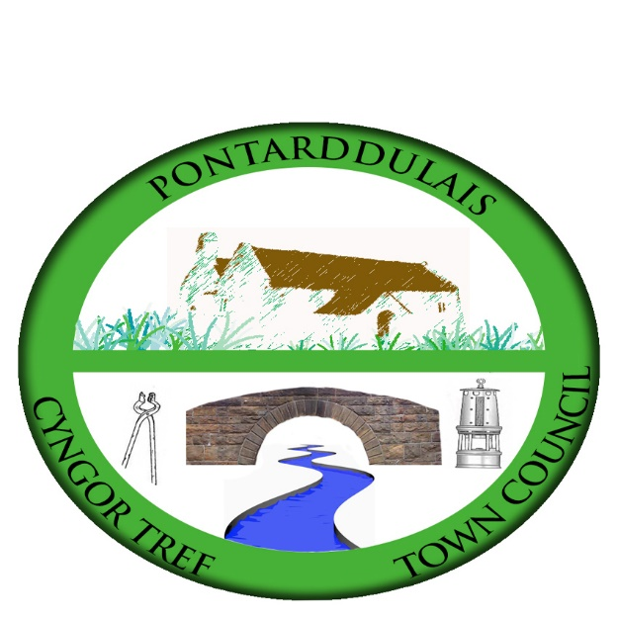

Email/Ebost: hilary.davies@pontarddulaistowncouncil.gov.uk
Website/Gwefan: www.pontarddulaistowncouncil.gov.uk

Correspondence is welcomed in English or Welsh / Croesewir gohebiaeth yn Gymraeg neu’n Saesneg

3 February 2023

A MEETING OF THE ESTATES AND DEVELOPMENT COMMITTEE WILL BE HELD IN THE INSTITUTE ON MONDAY 13TH FEBRUARY 2023 AT 7.00PM

H. J. Davies - Clerk to the Council

BUSINESS
1. Apologies for absence.

2. To receive declarations of personal interest from Members in accordance with the Council's Code of Conduct.

3. To elect a Chair

4. To agree Terms of Reference.

5. To consider/discuss the following requirements for the Institute:
  - Health & Safety/Risk Assessment for balcony
  - Service of kitchen boiler
  - Storage facilities for user groups
  - Improvement of internet facilities in the building and the provision of an electronic notice board in line with Digital Towns strategy
  - Display and safety of the valuable painting
  - Clarify the position of dogs in the building
  - Provision of baby changing facilities
  - External window cleaning on roof windows
  - Male toilet facilities
  - External barriers
  - Any other issues relating to the Institute
  - Hearing loop for the board room and main room

6. To consider and make recommendations on hire charges in the Institute.

