Clerc: H. J. Davies
45 Stryd Sant Teilo
Pontarddulais
ABERTAWE
SA4 8SY

Rhif ffôn: (01792) 883348
Ffôn symudol: 07969 050759

Clerk: H. J. Davies
45 St Teilo Street
Pontardulais
SWANSEA
SA4 8SY

Tel No: (01792) 883348
Mobile: 07969 050759

CYNGOR TREF PONTARDDULAIS TOWN COUNCIL
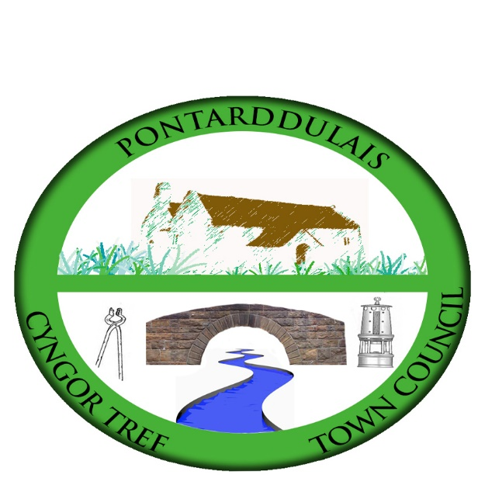

Email/Ebost: hilary.davies@pontarddulaistowncouncil.gov.uk
Website/Gwefan: www.pontarddulaistowncouncil.gov.uk

Correspondence is welcomed in English or Welsh / Croesewir gohebiaeth yn Gymraeg neu’n Saesneg

3 February 2023

A MEETING OF THE ESTATES AND DEVELOPMENT COMMITTEE WILL BE HELD IN THE INSTITUTE ON MONDAY 13TH MARCH 2023 AT 7.00PM

H. J. Davies - Clerk to the Council

BUSINESS
1. Apologies for absence.
2. To receive declarations of personal interest from Members in accordance with the Council's Code of Conduct.
3. To elect a Chair
4. To agree revised Terms of Reference.
5. To update on the following matters discussed at the previous meeting:
  - Health & Safety/Risk Assessment for balcony
  - Service of kitchen boiler
  - Storage facilities for user groups
  - Improvement of internet facilities in the building and the provision of an electronic notice board in line with Digital Towns strategy
  - Display and safety of the valuable painting
  - Clarify the position of dogs in the building
  - Provision of baby changing facilities
  - Male toilet facilities
  - External barriers
  - Any other issues relating to the Institute
  - Hearing loop for the board room and main room

6. Upgrade of kitchen and toilet area and site meeting.
7. Consider proposals received to treat damp issue.
8. Update on Skateboard park proposal.

