Clerk: H. J. Davies

45 St Teilo Street

Pontardulais

SWANSEA

SA4 8SY

Tel No: (01792) 883348

Mobile: 07939 592168

Clerc: H. J. Davies

45 Stryd Sant Teilo

Pontarddulais

ABERTAWE

SA4 8SY

Rhif ffôn: (01792) 883348

Ffôn symudol: 07939 592168

**CYNGOR TREF PONTARDDULAIS TOWN COUNCIL**



Email/Ebost: [clerk@pontarddulaistowncouncil.gov.uk](mailto:clerk@pontarddulaistowncouncil.gov.uk)

Website/Gwefan: www.pontarddulaistowncouncil.gov.uk

*Correspondence is welcomed in English or Welsh / Croesewir gohebiaeth yn Gymraeg neu’n Saesneg*



31 March 2023

Dear Councillor,

You are summoned to a meeting of Pontarddulais Town Council which will be held in person in the Council Chamber/Room 1, Mechanics Institute, 45 St Teilo Street, Pontarddulais on Thursday, 6th April 2023 at 7.00 p.m. for the purpose of transacting the business specified below.

Yours faithfully

*H. J. Davies*

Clerk to the Council

15 minutes prior to the meeting members of the public will be allowed to ask questions.

**BUSINESS**

* 1. Apologies for absence.
  2. To receive declarations of personal and/or prejudicial interest from Members in accordance with the Council’s Code of Conduct.
  3. To receive Declarations of Acceptance of Office from newly co-opted Councillors.
  4. To sign the minutes of the Council meeting held on the 2nd March 2023 (copy attached).
  5. Special Events Committee meeting held on 21st March 2023_v3:
* To receive and consider the minutes (copy attached)
  1. Estates & Development Committee meeting held on the 20th March 2023_V2:
* To receive and consider the minutes (copy attached).
  1. Policy & Resources Committee meeting held meeting held on the 23rd March 2023_V2
* To receive and consider the minutes (copy attached)
  + Job description: Cleaner. Recommended for approval by Council.
  + Recommendation to Council to approve purchase of Flick training software for the 20 users pricing plan.
* To consider and approve the Hire of Hall Policy (copy attached V3).
* To consider and approve the use of an external facilitator to support the Council long-term vision and values planning workshop(s) (attached - HICO quote).
* King’s Coronation.
  1. To receive an update on defibrillators.

1. To receive reports from County Ward Members.
2. To receive and consider any urgent matters from Town Councillors.
3. A special motion and written notice was received to revoke the resolution passed at the last council meeting, part 2 of minute 168, where it says ‘It was agreed that the Council meeting room return to meeting room 3. Large tables to be moved upstairs and tables in meeting room 1 changed to foldable tables to give more flexibility to the room’.

Cllr P. Downing

Cllr A. Wilson

**The proposal put by the Councillor at the meeting and voted on, has since been withdrawn.**

1. A request has been received to appoint an event organisation company to support aspects of the organisation of the Summer Festival in June.
2. To answer questions from Councillors (3 working days’ notice of any question having been given to the person to whom it is addressed).

The following question was given to the two county councillors, Cllr P. Downing and Cllr K. Griffiths, to respond individually or jointly together:

* Garnswllt road flooding - can they confirm works will be carried out this year to address this issue, as the highways have been aware of the situation for a number of years and all work they have previously conducted has been to help get the water off the road rather than solving the cause by dredging or building banks to stop the flooding higher up the river What will the work look like?

1. To receive and consider reports from the Clerk to the Council.
2. To receive any announcements from the Town Mayor.
3. To receive and consider reports from representatives on outside bodies.
4. Request of Motion of Exclusion of Public and Press – S.1(2) Public Bodies (Admission to Meetings) Act 1960 for the following item:

* To consider the remuneration of the Clerk for hours owed. (To follow).

1. To authorise and approve the expenditure for the month of March 2023 (copy to follow).
2. To receive a monthly income report and bank reconciliation for the month of March 2023 (copy to follow).
3. To receive planning applications previously circulated to all Members (Appendix A).

**APPENDIX A**

**Planning Decisions and Applications March 2023**

**WEEKLY DECISION - WEEK ENDING:24th March 2023**

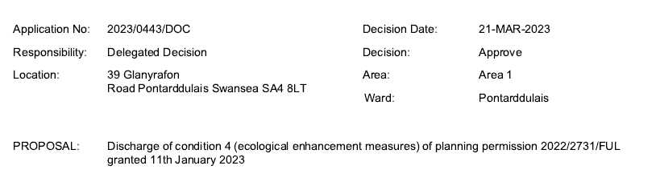

**WEEKLY LIST OF PLANNING APPLICATIONS REGISTERED**

**WEEK ENDING: 24th March 2023**

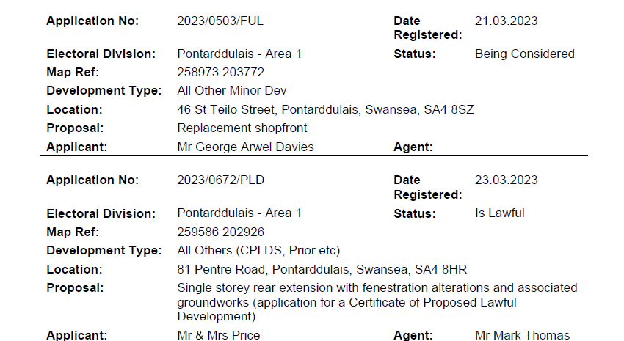

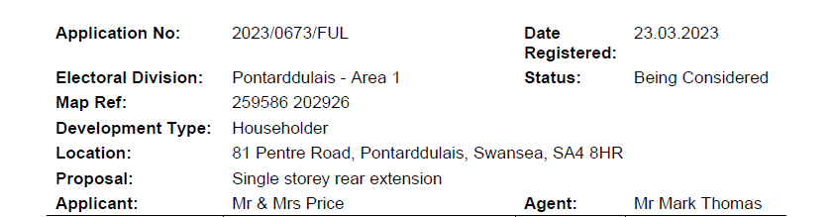

**WEEKLY DECISION - WEEK ENDING:17th March 2023**

No decisions received

**WEEKLY LIST OF PLANNING APPLICATIONS REGISTERED**

**WEEK ENDING: 17th March 2023**

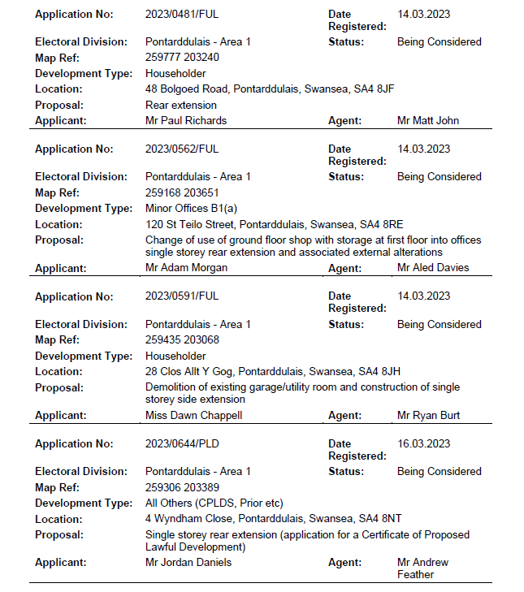

**WEEKLY DECISION - WEEK ENDING: 10th March 2023**

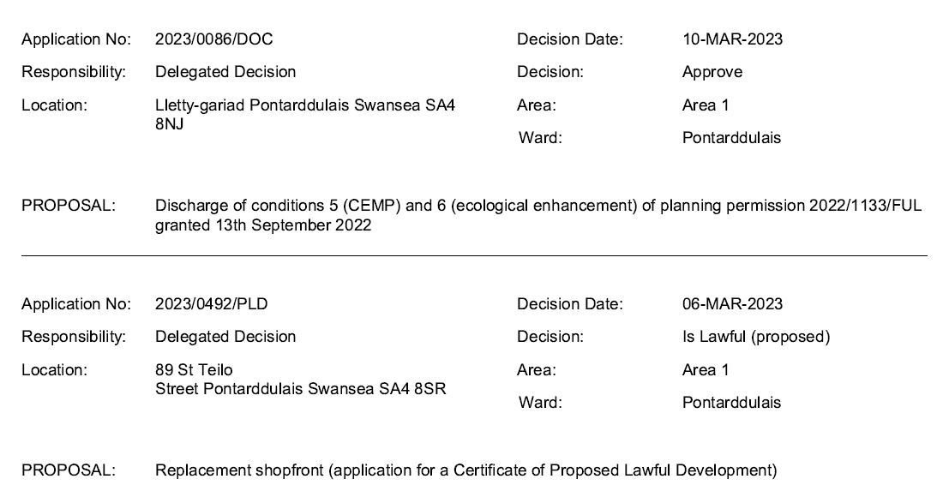

**WEEKLY LIST OF PLANNING APPLICATIONS REGISTERED**

**WEEK ENDING: 10th March 2023**

No applications received

**WEEKLY DECISION - WEEK ENDING: 3rd March 2023**

**WEEKLY LIST OF PLANNING APPLICATIONS REGISTERED**

**WEEK ENDING: 3rd March 2023**

