Clerc: H. J. Davies
45 Stryd Sant Teilo
Pontarddulais
ABERTAWE
SA4 8SY

Rhif ffôn: (01792) 883348
Ffôn symudol: 07939 592168

Clerk: H. J. Davies
45 St Teilo Street
Pontardulais
SWANSEA
SA4 8SY

Tel No: (01792) 883348
Mobile: 07939 592168

CYNGOR TREF PONTARDDULAIS TOWN COUNCIL
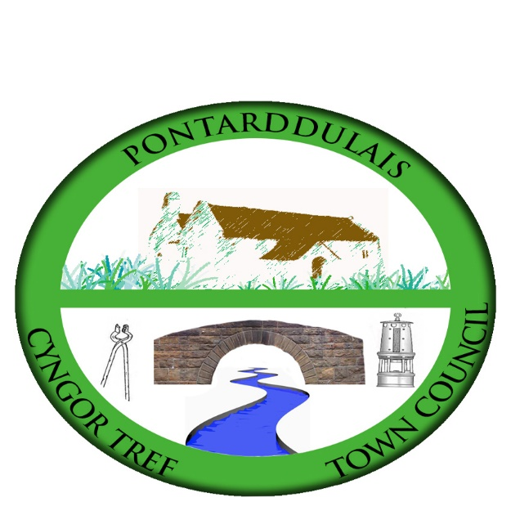

Email/Ebost: hilary.davies@pontarddulaistowncouncil.gov.uk
Website/Gwefan: www.pontarddulaistowncouncil.gov.uk

Correspondence is welcomed in English or Welsh / Croesewir gohebiaeth yn Gymraeg neu’n Saesneg

28 February 2024

A MEETING OF THE SPECIAL EVENTS COMMITTEE WILL BE HELD IN THE INSTITUTE ON TUESDAY 19th MARCH 2024 AT 7.00 PM

Council meetings are recorded for minute taking purposes and are deleted once minutes are agreed.

H. J. Davies - Clerk to the Council

BUSINESS

- Apologies for absence.
- To receive declarations of personal interest from Members in accordance with the
Council's Code of Conduct.
- Minutes of last meeting for any outstanding actions
- Events plan
    - D Day
    - Festival
    - Summer Quiz
    - Remembrance Service
- Christmas 2024
    - Parade event
        - Dulais Glen
        - Dantwyn
    - Santa’s Grotto
    - Pantomime
- Budget

