Clerc: H. J. Davies
45 Stryd Sant Teilo
Pontarddulais
ABERTAWE
SA4 8SY

Rhif ffôn: (01792) 883348
Ffôn symudol: 07969 050759

Clerk: H. J. Davies
45 St Teilo Street
Pontardulais
SWANSEA
SA4 8SY

Tel No: (01792) 883348
Mobile: 07969 050759

CYNGOR TREF PONTARDDULAIS TOWN COUNCIL
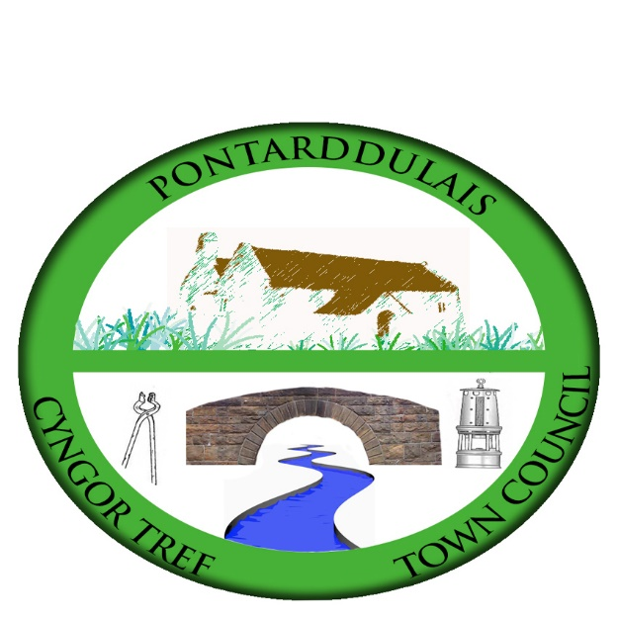

Email/Ebost: hilary.davies@pontarddulaistowncouncil.gov.uk
Website/Gwefan: www.pontarddulaistowncouncil.gov.uk

Correspondence is welcomed in English or Welsh / Croesewir gohebiaeth yn Gymraeg neu’n Saesneg
26 January 2024

A MEETING OF THE ESTATES, DEVELOPMENT & CULTURE COMMITTEE WILL BE HELD IN THE INSTITUTE ON THURSDAY 1st FEBRUARY 2024 AT 7.00PM

H. J. Davies - Clerk to the Council

BUSINESS

- Apologies for absence
- To receive declarations of personal interest from Members in accordance with the Council’s Code of Conduct
- Review actions from previous meeting (attached)
- Budget
  - Review budget
- Institute building:
  - Damp issues
  - Bookings
- Gerallt Davies memorial
- Active travel route
- Actions from Council meeting 18 January 2024
- Banking facilities (Cllr S Lloyd-Janes)

