
Clerk: Susan Rodaway
45 St Teilo Street
Pontardulais
SWANSEA
SA4 8SY

Tel No: (01792) 803783
Mobile: 07939 592168

Clerc: Susan Rodaway
45 Stryd Sant Teilo
Pontarddulais
ABERTAWE
SA4 8SY

Rhif ffôn: (01792) 803783
Ffôn symudol: 07939 592168
CYNGOR TREF PONTARDDULAIS TOWN COUNCIL

Email/Ebost: clerk@pontarddulaistowncouncil.gov.uk
Website/Gwefan: www.pontarddulaistowncouncil.gov.uk

Correspondence is welcomed in English or Welsh / Croesewir gohebiaeth yn Gymraeg neu’n Saesneg
Dear Member

You are hereby summoned to attend the Policy, Compliance and Finance Committee Meeting, of Pontarddulais Town Council in the Council Chamber/Room 1, Mechanics Institute, 45 St Teilo Street, Pontarddulais on Tuesday 24th March 2026 at 7.00pm

If you wish to attend the meeting remotely, please contact the Clerk at clerk@pontarddulaistowncouncil.gov.uk for the Teams link
by Midday on Monday 23rd March 2026

Council meetings are recorded for minute taking purposes and are deleted once minutes are agreed.

Apologies for Absence
Declarations of Interest
Questions from the public relating to items on the agenda. (limited to 15 minutes)

Agenda

- To complete random audit of February payments
- To note February 2026 closing balances
- To agree March payments made and anticipated for recommendation to Full Council
- Review of Internal Audit procedure
- To agree informal group for review of internal controls
- To agree appointment of internal auditor.

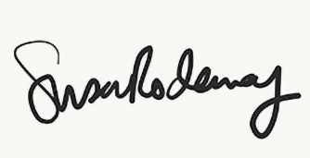

Susan Rodaway
Town Clerk
18/03/2026

