CYNGOR TREF PONTARDDULAIS TOWN COUNCIL
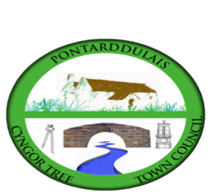
Clerc: Susan Rodaway
45 Stryd Sant Teilo
Pontarddulais
ABERTAWE
SA4 8SY

Rhif ffôn: (01792) 803783
Ffôn symudol: 07939 592168
Clerk: Susan Rodaway
45 St Teilo Street
Pontardulais
SWANSEA
SA4 8SY

Tel No: (01792) 803783
Mobile: 07939 592168

Email/Ebost: clerk@pontarddulaistowncouncil.gov.uk
Website/Gwefan: www.pontarddulaistowncouncil.gov.uk

Correspondence is welcomed in English or Welsh / Croesewir gohebiaeth yn Gymraeg neu’n Saesneg
Dear Member
You are hereby summoned to attend the Planning Committee Meeting, of Pontarddulais Town Council online only on Wednesday 15th July 2026 at 7pm.

If you wish to attend the meeting remotely, please contact the Clerk at clerk@pontarddulaistowncouncil.gov.uk for the Teams link
By Midday on Tuesday 14th July 2026.

Council meetings are recorded for minute-taking purposes and are deleted once minutes are agreed.
Apologies for Absence
Declarations of Interest
Questions from the public relating to items on the agenda. (limited to 15 minutes)

AGENDA
- 2026/1006/FUL
Single storey rear extension
21 Bolgoed Road, Pontarddulais, Swansea, SA4 8JE
- Premises License
Indoor Sporting Events:
Monday – Saturday 10.00-23.00
Sunday 11.00-22.00
Sale of Alcohol:
Monday – Saturday 11.00-22.30
Sunday 11.00-21.30
- To discuss and agree a response to the Democracy and Boundary Commission Cymru’s survey of Town and Community Councils in Wales
- To discuss the benefits of a Community Place Plan and agree a way forward.

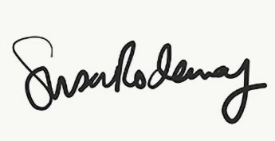
Susan Rodaway
Town Clerk and RFO
Pontarddulais Town Council
10/07/2026

