CYNGOR TREF PONTARDDULAIS TOWN COUNCIL

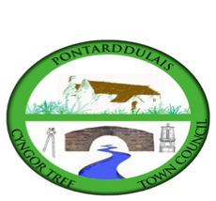
Clerk: Susan Rodaway
45 St Teilo Street
Pontardulais
SWANSEA
SA4 8SY

Tel No: (01792) 803783
Mobile: 07939 592168

Clerc: Susan Rodaway
45 Stryd Sant Teilo
Pontarddulais
ABERTAWE
SA4 8SY

Rhif ffôn: (01792) 803783
Ffôn symudol: 07939 592168

Email/Ebost: clerk@pontarddulaistowncouncil.gov.uk
Website/Gwefan: www.pontarddulaistowncouncil.gov.uk

Correspondence is welcomed in English or Welsh / Croesewir gohebiaeth yn Gymraeg neu’n Saesneg
Dear Member
You are hereby summoned to attend the Annual Meeting, of Pontarddulais Town Council in the Council Chamber/Room 1, Mechanics Institute, 45 St Teilo Street, Pontarddulais, and online on Tuesday 19th May 2026 at 7.00 pm

If you wish to attend the meeting remotely, please contact the Clerk at clerk@pontarddulaistowncouncil.gov.uk for the Teams link
By Monday 18th May 2026
Council meetings are recorded for minute-taking purposes and are deleted once the minutes are agreed.

Questions from the public relating to items on the agenda. (limited to 15 minutes)

Annual Meeting Agenda
- Election of Mayor 2026/27.
- Apologies for Absence
- Declarations of Interest
- Election of Vice Chair 2026/27.
- Financial Matters
  - To consider and approve the annual accounts.
  - To discuss and approve the budget and action plan for the upcoming year.
  - To note RFO signing Annual Return and sending the required documents to the internal auditor.
  - To approve Cllr. Remuneration Report 2025/26.
  - To agree optional Cllr. Remuneration levels for 2026/27.
  - To review and agree the Council’s expenditure incurred under s.137 of the Local Government Act 1972 or the power of well-being.
  - To note the s137 spend limit for 2025/26.
  - To agree the Council’s and/or staff subscriptions to other bodies.
  - To Approve List of Regular Monthly Payments for 2026/27.
  - To agree the Asset Register as at 1st May 2026 and agree review by Clerk/RFO and Chair of Policy. Compliance and Finance.
  - Confirmation of the Council’s Insurance arragements
- Committee Appointments
  - To appoint members to Planning, HR and Training, Estates and Environment, Special Events and Welsh Language Committees.
  - To appoint Chairs of Planning, HR and Training, Estates and Environment, Special Events and Welsh Language Committees.
  - To appoint Chair of Policy, Compliance and Finance Committee.
  - To appoint members of Policy, Compliance and Finance Committee.
  - Review of representatives on external bodies: OVW Area Committee, Swansea Town and Community Council Forum, OVW Larger Council’s Committee.
- Policy Reviews
  - To review and agree Council Standing Orders
  - To review and agree Council’s Financial Regulations.
  - To adopt the bilingual Code of Conduct 2016
  - To review and agree Financial and Operational Risk Assessment
  - To agree to Clerk and Chair of Policy, Compliance and Finance carrying out a review of financial internal controls.
  - To review and agree policies
  - To approve the delegation arrangements for the Clerk
  - To approve the delegation arrangements and terms of reference for Committees and Sub-Committees.
- Electors’ Rights
  - To note the dates for the Exercise of Public Rights.
- To agree the planned time and date of ordinary meetings of the Council up to and including the next annual meeting of the Council.

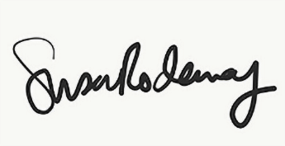
Susan Rodaway
Town Clerk and RFO
Pontarddulais Town Council
14/05/2026

