
Clerk: Susan Rodaway
45 St Teilo Street
Pontardulais
SWANSEA
SA4 8SY

Tel No: (01792) 803783
Mobile: 07939 592168

Clerc: Susan Rodaway
45 Stryd Sant Teilo
Pontarddulais
ABERTAWE
SA4 8SY

Rhif ffôn: (01792) 803783
Ffôn symudol: 07939 592168
CYNGOR TREF PONTARDDULAIS TOWN COUNCIL

Email/Ebost: clerk@pontarddulaistowncouncil.gov.uk
Website/Gwefan: www.pontarddulaistowncouncil.gov.uk

Correspondence is welcomed in English or Welsh / Croesewir gohebiaeth yn Gymraeg neu’n Saesneg
Dear Member

You are hereby summoned to attend the Policy, Compliance and Finance Committee Meeting, of Pontarddulais Town Council in the Council Chamber/Room 1, Mechanics Institute, 45 St Teilo Street, Pontarddulais on Tuesday 27th January 2026 at 7.00pm

If you wish to attend the meeting remotely, please contact the Clerk at clerk@pontarddulaistowncouncil.gov.uk for the Teams link
by Monday 26th November 2026

Council meetings are recorded for minute taking purposes and are deleted once minutes are agreed.

Policy, Compliance and Finance Committee Meeting Agenda

- To complete random audit of November and December payments
- To note December Closing balances
- To note end of Qtr. 3 closing balances 2025/26
- To review budget proposed by all Council Committees for 2026/27
- To agree budget required for 2026/2027 financial year for recommendation to Full Council
- To agree precept for 2026/2027 financial year for recommendation to Full Council

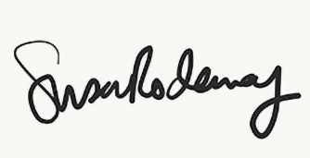

Susan Rodaway
Town Clerk
23/01/2026

