CYNGOR TREF PONTARDDULAIS TOWN COUNCIL
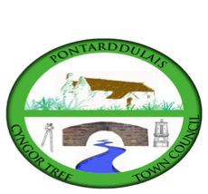
Clerc: Susan Rodaway
45 Stryd Sant Teilo
Pontarddulais
ABERTAWE
SA4 8SY

Rhif ffôn: (01792) 803783
Ffôn symudol: 07939 592168
Clerk: Susan Rodaway
45 St Teilo Street
Pontardulais
SWANSEA
SA4 8SY

Tel No: (01792) 803783
Mobile: 07939 592168

Email/Ebost: clerk@pontarddulaistowncouncil.gov.uk
Website/Gwefan: www.pontarddulaistowncouncil.gov.uk

Correspondence is welcomed in English or Welsh / Croesewir gohebiaeth yn Gymraeg neu’n Saesneg
Dear Member
You are hereby summoned to attend the Welsh Language Committee Meeting, of Pontarddulais Town Council online only on Monday 23rd February 2026 at 7pm.

If you wish to attend the meeting remotely, please contact the Clerk at clerk@pontarddulaistowncouncil.gov.uk for the Teams link
By Midday on Monday 23rd February 2026.

Council meetings are recorded for minute-taking purposes and are deleted once minutes are agreed.

Apologies for Absence
Declarations of Interest
Questions from the public relating to items on the agenda. (limited to 15 minutes)

AGENDA

- To appoint a Vice-Chair
- To consider new Welsh Language Policy and agree a way forward.

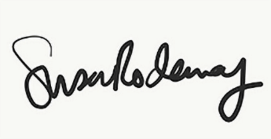
Susan Rodaway
Town Clerk and RFO
Pontarddulais Town Council
20/02/2026

