CYNGOR TREF PONTARDDULAIS TOWN COUNCIL
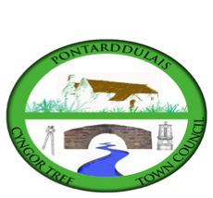
Clerc: Susan Rodaway
45 Stryd Sant Teilo
Pontarddulais
ABERTAWE
SA4 8SY

Rhif ffôn: (01792) 803783
Ffôn symudol: 07939 592168
Clerk: Susan Rodaway
45 St Teilo Street
Pontardulais
SWANSEA
SA4 8SY

Tel No: (01792) 803783
Mobile: 07939 592168

Email/Ebost: clerk@pontarddulaistowncouncil.gov.uk
Website/Gwefan: www.pontarddulaistowncouncil.gov.uk

Correspondence is welcomed in English or Welsh / Croesewir gohebiaeth yn Gymraeg neu’n Saesneg
Dear Member
You are hereby summoned to attend the Planning Committee Meeting, of Pontarddulais Town Council online only on Tuesday 10th March 2026 at 7pm.

If you wish to attend the meeting remotely, please contact the Clerk at clerk@pontarddulaistowncouncil.gov.uk for the Teams link
By Midday on Monday 9th February 2026.

Council meetings are recorded for minute-taking purposes and are deleted once minutes are agreed.

Apologies for Absence
Declarations of Interest
Questions from the public relating to items on the agenda. (limited to 15 minutes)

AGENDA
- Ref No: 2026/0206/FUL
Development of 95 dwellings and associated works including access, drainage, landscaping, and associated infrastructure.
Land At Bolgoed Farm, Napier Road, Pontarddulais Swansea, SA4 8JP

- 2026/0066/PLD
Use of property as a care home for children and young people, installation of replacement windows, new roof covering and erection of 1.8m fencing and gate to side and rear (application for a Certificate of Proposed Lawful Development)
Craigle Garnswllt Road Pontarddulais Swansea SA4 8QG

- 2025/1189/FUL/CAS-04765-N5H4G9
Rear ground floor extension. Roof extension by raising the ridge and extension over the rear flat roof extension
21 Twyniago Pontarddulais Swansea SA4 8HX
For information only – appeal to Welsh Government
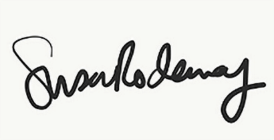
Susan Rodaway
Town Clerk and RFO
Pontarddulais Town Council
05/03/2026

