Cyngor Tref Pontarddulais Town Council



Complaints and Concerns Form

Adopted: May 2026
Amended: N/A
For Review: May 2027

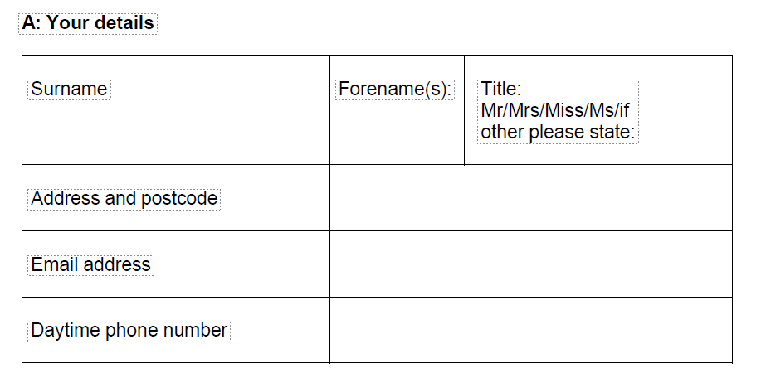

Your requirements

If our usual way of dealing with complaints makes it difficult for you to use our service, for example if English or Welsh is not your first language or you need to engage with us in a particular way, please tell us so that we can discuss how we might help you.

The person who has experienced the problem should normally fill in this form.

If you are filling this in on behalf of someone else, please fill in section B. Please note that before taking forward the complaint we will need to satisfy ourselves that you have the authority to act on behalf of the person concerned.

B: Making a complaint on behalf of someone else: Their details

Their name in full
Address and postcode
Why are you making a complaint on their behalf?
What is your relationship to them?

C: About your concern/complaint (Please continue your answers to the following questions on a separate sheet(s) if necessary)

Describe the service you are complaining about
What do you think we did wrong or failed to do?
Describe how you or the person you are acting for has personally suffered or been affected.
What do you think should be done to put things right?
When did you first become aware of the problem?
Have you already put your concern to the frontline staff responsible for delivering the service? If so, please give brief details of how and when you did so.
If it is more than 12 months since you became first aware of the problem, please give the reason why you have not complained before now.

If you have any documents to support your concern/complaint, please submit them with this form.

Full name: Signature: Date:

