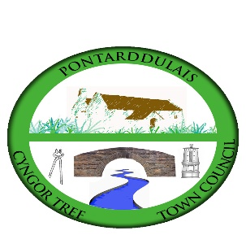

**CYNGOR TREF PONTARDDULAIS TOWN COUNCIL**

**APPLICATION FOR FINANCIAL ASSISTANCE (MAX AWARD £250)**

1. **Name of Group:**

**Address:**

**Telephone:**

**E-mail:**

**Contact name:**

1. **Please provide a summary of your organisation’s objectives and core activities (max 50 words):**
2. **What would your organisation spend this money on? (max 100 words)**
3. **How would this benefit the community in Pontarddulais? (max 100 words)**

**Signed:**

**Position:**

Please return your completed application, along with a copy of your groups latest balance sheet (example provided in accompanying document) **via email** to: [clerk@pontarddulaistowncouncil.gov.uk](mailto:clerk@pontarddulaistowncouncil.gov.uk)

Hard copies can be delivered to

Mrs Susan Rodaway

Clerk to the Council

Cyngor Tref Pontarddulais Town Council

The Institute

45 St Teilo Street

Pontarddulais

SA4 8SY

Contact details for queries: Mobile: 07939 592168 / Office: 01792 803783

**The closing date for applications is 5.00pm, 14th February 2025.**

**Please note no applications will be considered after the closing date.**

If your application is successful the money will be transferred electronically into the groups bank account, therefore please supply the following bank details:

**Name of account**:

**Sort code**:

**Account number**: