CYNGOR TREF PONTARDDULAIS TOWN COUNCIL
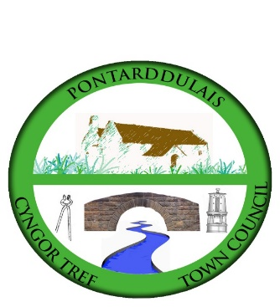
Clerk: Susan Rodaway
45 St Teilo Street
Pontardulais
SWANSEA
SA4 8SY

Tel No: (01792) 803783
Mobile: 07939 592168

Clerc: Susan Rodaway
45 Stryd Sant Teilo
Pontarddulais
ABERTAWE
SA4 8SY

Rhif ffôn: (01792) 803783
Ffôn symudol: 07939 592168

Email/Ebost: clerk@pontarddulaistowncouncil.gov.uk
Website/Gwefan: www.pontarddulaistowncouncil.gov.uk

Correspondence is welcomed in English or Welsh / Croesewir gohebiaeth yn Gymraeg neu’n Saesneg
Dear Member

You are hereby summoned to attend the Planning Committee Meeting, of Pontarddulais Town Council online only on Tuesday 18th February 2025 at 7.00 pm.

If you wish to attend the meeting remotely, please contact the Clerk at clerk@pontarddulaistowncouncil.gov.uk for the Teams link
by Monday 17th February 2024

AGENDA
Apologies for Absence
Disclosures of Personal and Prejudicial interests in accordance with the Council’s Code of Conduct. Members are requested to identify the Agenda Item/Minute Number and Subject Matter that their interest relates to (these can also be taken during the meeting).
Questions from the public (limited to 15 minutes)

- Applications for Consideration

- 2023/1168/FUL
Former Clayton Works Tyn Y Bonau Road Pontarddulais Swansea SA4 8RU
Erection of 29 residential units, access works, car parking, landscaping and associated works
- 2024/1641/FUL
Site Location: 6 Gorsaf Y Glowr Pontarddulais Swansea SA4 8JJ
Proposal: Change of use from dwellinghouse (Class C3) to residential care home for up to 5 adults (Class C2), conversion of garage to office use and 1.8m high gates and boundary treatment (amended plans and information received)
- 2025/0006/FUL
Ynys House Garnswllt Road Pontarddulais Swansea SA4 8QH
Replacement of an existing stable with a new stable on the same site
- 2025/0154/PLD
Skatepark Coed Bach Park Gwynfryn Road Pontarddulais Swansea SA4 8LG
Refurbishment of existing skatepark involving removal of existing ramps and cabin/shelter, provision of new ramps in colour tinted concrete, new access path and seating area with bins and benches.
- To note receipt of draft Swansea Local Development Plan 2023-2028 (LDP2) document and to consider candidate sites included in the proposed first draft.
- To agree a way forward following receipt of draft LDP2.
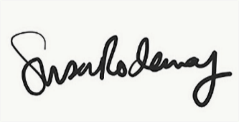
Susan Rodaway
Town Clerk/RFO
13/02/2025

