CYNGOR TREF PONTARDDULAIS TOWN COUNCIL
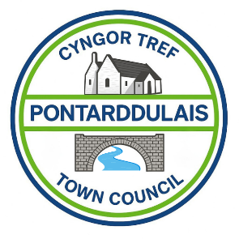
Clerc: Susan Rodaway
45 Stryd Sant Teilo
Pontarddulais
ABERTAWE
SA4 8SY

Rhif ffôn: (01792) 803783
Ffôn symudol: 07939 592168
Clerk: Susan Rodaway
45 St Teilo Street
Pontardulais
SWANSEA
SA4 8SY

Tel No: (01792) 803783
Mobile: 07939 592168

Email/Ebost: clerk@pontarddulaistowncouncil.gov.uk
Website/Gwefan: www.pontarddulaistowncouncil.gov.uk

Correspondence is welcomed in English or Welsh / Croesewir gohebiaeth yn Gymraeg neu’n Saesneg
Dear Member

You are hereby summoned to attend the Ordinary Council Meeting, of Pontarddulais Town Council in the Council Chamber/Room 1, Mechanics Institute, 45 St Teilo Street, at 7pm on Thursday 3rd September 2026.
If you wish to attend the meeting remotely, please contact the Clerk at clerk@pontarddulaistowncouncil.gov.uk for the Teams link
by Midday on Wednesday 2nd September 2026
Council meetings are recorded by the Town Clerk for minute-taking purposes and are deleted once the minutes are agreed. Recording by any other means/persons is prohibited.

Presentation by Place & Space regarding Swansea Heritage Project.
Reports from County Councillors
Report from local Police

Apologies for Absence
Disclosures of Personal and Prejudicial interests in accordance with the Council’s Code of Conduct.
Questions from the public relating to items on the agenda. (limited to 15 minutes)

FULL COUNCIL ORDINARY MEETING AGENDA

- To receive and accept the minutes of the Ordinary Full Council Meeting 2nd July 2026.
- To receive and accept the minutes of the Planning Committee Meeting 15th July 2026
- To receive and accept the minutes of the Extraordinary Full Council Meeting 16th July 2026
- To receive and accept the minutes of the Policy Compliance and Finance Committee Meeting 29th July 2026
- To receive and accept the minutes of the Special Events Committee Meeting 29th July 2026
- To receive and accept the minutes of the Planning Committee Meeting 18th August 2026
- Policy, Compliance & Finance (PCF)
- To note Civic Budget, spend since the last meeting (£750 total for year):
£50 donation to Cor Glandulais Pontarddulais.
£50 donation to Pontarddulais Rugby Club.
£23.92 Bont Matters Meeting refreshments.
(remaining: £469.91 excl. VAT)
- To note June closing balances
- To accept end of Qtr. 1 closing balances and transactions
- To review Qtr. 1 Budget vs actual and agree no virements required
- To approve Qtr. 1 VAT return for submission to HMRC
- To ratify July payments made.
- To note July closing balances
- Update on any grant application in progress or applied for and not discussed elsewhere on this agenda.
- To agree to fund the remaining shortfall for Dantwyn Park from the general fund.
- Planning
To note two planning enforcement reports made this month.
- Estates and Environment (EE)
- Update only on items not covered elsewhere on the agenda
- To discuss and agree Landline/Broadband contractor due to end of current contract with BT.
- To note installation of emergency alarm in disabled toilet.
- To discuss request from Theatr Bontastic for support to begin weekly sessions.
- To discuss the possibility of purchasing a building to create youth services in the community and agree a way forward.
- Special Events (SE)
- Update only on items not covered elsewhere on this agenda
- Update on Summer Fair, including budget to date.
- To discuss “thank you” gift for Town Council volunteer at Summer Fair
- To note successful completion of the Summer activities supported by Swansea Council Wellbeing Fund, and receive feedback.
- To note a successful first “Bont Matters” session and receive feedback.
- To agree to set up a Film Club for Pontarddulais and agree a way forward.

- HR and Training (HR&T)
- To receive reports from Councillors who attended training courses/conferences since the last meeting.
- Report on Civility and Respect training, delivered by Council Culture, in person, on Tuesday 28th July.

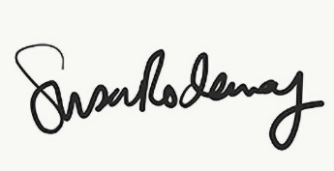
Susan Rodaway
Town Clerk and RFO
Pontarddulais Town Council
28/08/2026

