`
CYNGOR TREF PONTARDDULAIS TOWN COUNCIL


Clerk: Susan Rodaway
45 St Teilo Street
Pontardulais
SWANSEA
SA4 8SY

Tel No: (01792) 803783
Mobile: 07939 592168

Clerc: Susan Rodaway
45 Stryd Sant Teilo
Pontarddulais
ABERTAWE
SA4 8SY

Rhif ffôn: (01792) 803783
Ffôn symudol: 07939 592168

Email/Ebost: clerk@pontarddulaistowncouncil.gov.uk
Website/Gwefan: www.pontarddulaistowncouncil.gov.uk

Correspondence is welcomed in English or Welsh / Croesewir gohebiaeth yn Gymraeg neu’n Saesneg
Dear Member

You are hereby summoned to attend the Extraordinary Council Meeting, of Pontarddulais Town Council in the Council Chamber/Room 1, Mechanics Institute, 45 St Teilo Street, at 7pm on Thursday 28th May 2026.
If you wish to attend the meeting remotely, please contact the Clerk at clerk@pontarddulaistowncouncil.gov.uk for the Teams link
by Midday on Wednesday 27th May 2026
Council meetings are recorded by the Town Clerk for minute-taking purposes and are deleted once the minutes are agreed. Recording by any other means/persons is prohibited.

Apologies for Absence
Disclosures of Personal and Prejudicial interests in accordance with the Council’s Code of Conduct.
Questions from the public relating to items on the agenda. (limited to 15 minutes)

Opportunity to hear from applicants for Dulais East and West Casual Vacancies.

EXTRAORDINARY MEETING AGENDA

- To receive applications for casual vacancies in Dulais East and West (one in each ward).

- To discuss applications and agree successful applicants for Dulais East and West vacancies.

- Policy, Compliance & Finance (PCF)
- To note March 2026 closing balances
- To approve April 2026 payments made
- To note VAT reclaim for Qtr. 2, Qtr. 3, and Qtr. 4 2025/26
- To note creation of Direct Debit to Octopus for all accounts
- To note receipt of £375 in introduction payments from Octopus, credited to new accounts.

- Items deferred from Annual Meeting 2026
  - To review and agree Council Standing Orders
  - To review and agree Council’s Financial Regulations.
  - To adopt the bilingual Code of Conduct 2016
  - To review and agree Financial and Operational Risk Assessment
  - To agree that the Clerk and Chair of Policy, Compliance and Finance carry out a review of financial internal controls.
  - To review and agree policies
  - To approve the delegation arrangements and terms of reference for the Policy, Compliance and Finance (PCF) Committee
  - To agree membership of PCF Committee
  - To appoint Chair of PCF Committee
  - To approve the delegation arrangements for the Clerk

- Special Events (SE) To note change of date of Summer Fair due to lack of time/capacity of staff and members.

- HR and Training (HR&T) To agree date for Civility and Respect training, delivered by Council Culture in person.

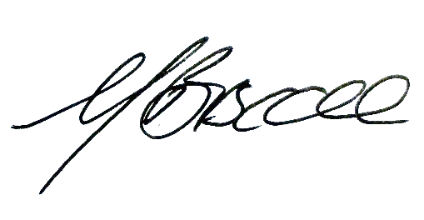
Mark Biscoe
Mayor
Pontarddulais Town Council
22/05/2026

