CYNGOR TREF PONTARDDULAIS TOWN COUNCIL

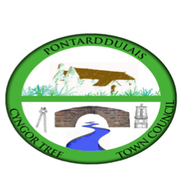
Clerk: Susan Rodaway
45 St Teilo Street
Pontardulais
SWANSEA
SA4 8SY

Tel No: (01792) 803783
Mobile: 07939 592168

Clerc: Susan Rodaway
45 Stryd Sant Teilo
Pontarddulais
ABERTAWE
SA4 8SY

Rhif ffôn: (01792) 803783
Ffôn symudol: 07939 592168

Email/Ebost: clerk@pontarddulaistowncouncil.gov.uk
Website/Gwefan: www.pontarddulaistowncouncil.gov.uk

Correspondence is welcomed in English or Welsh / Croesewir gohebiaeth yn Gymraeg neu’n Saesneg
Dear Member

You are hereby summoned to attend the Ordinary Council Meeting, of Pontarddulais Town Council in the Council Chamber/Room 1, Mechanics Institute, 45 St Teilo Street, Pontarddulais, and online on Tuesday 29th April 2025 at 7.00 pm

If you wish to attend the meeting remotely, please contact the Clerk at clerk@pontarddulaistowncouncil.gov.uk for the Teams link
by Monday 28th April 2025
Council meetings are recorded for minute-taking purposes and are deleted once the minutes are agreed.

Reports from County Councillors
Cllr. Kevin Griffiths
Cllr. Philip Downing
Report from local Police

Questions from the public relating to items on the agenda. (limited to 15 minutes)
Apologies for Absence
Disclosures of Personal and Prejudicial interests in accordance with the Council’s Code of Conduct.

FULL COUNCIL ORDINARY MEETING AGENDA

- Accuracy and Approval of the minutes of the Estates and Environment Meeting 24th March 2025
- Accuracy and Approval of the minutes of the March Full Council Meeting 27th March 2025
- Accuracy and Approval of the minutes of the Special Events Meeting 1st April 2025

- Admin.
- To receive verbal reports from Councillors who attended training courses this month
- To agree any motion to send to One Voice Wales (OVW) for consideration for inclusion at their AGM
- To note potential changes to Standing Orders at the Annual Meeting May 8th 2025.

- Policy, Compliance & Finance
- To note March closing balances and April payments
- To note end of Qtr 1, 2, 3 and 4 closing balances.
- To note VAT reclaim 2024/25
- To receive an update on grant applications previously made and grant deadlines/applications
- To agree on the appointment of Mr. L. Llewellyn as Internal Auditor.
- To note receipt of Audit documentation and Timetable.
- To discuss and agree transfer of £5000 from earmarked reserves for Children’s Play to fund Summer Events if funding is not available from external sources.
- To discuss and agree Election of Mayor/Deputy Mayor policy.

- Estates
- Update on Kitchen Refurbishment
- To receive an update regarding Damp survey
- To note purchase of induction hob from Maintenance and Renewal Reserve due to failure of existing electric hob.
- Special Events
- Update on Easter Event.
- To discuss a way forward for Summer Events

It is proposed under the Public Bodies (Admission to Meetings) Act 1960, the public and representatives of the press and broadcast media be excluded from the meeting during the consideration of item 10 as publicity would be prejudicial to the public interest because of the confidential nature of the business to be transacted.

- HR and Training
a) To agree to adopt Model Protocol on Member/Officer Relations

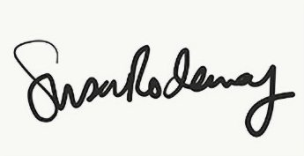
Susan Rodaway
Town Clerk and RFO
Pontarddulais Town Council
24/04/2025

