CYNGOR TREF PONTARDDULAIS TOWN COUNCIL

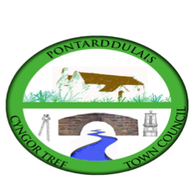
Clerk: Susan Rodaway
45 St Teilo Street
Pontardulais
SWANSEA
SA4 8SY

Tel No: (01792) 803783
Mobile: 07939 592168

Clerc: Susan Rodaway
45 Stryd Sant Teilo
Pontarddulais
ABERTAWE
SA4 8SY

Rhif ffôn: (01792) 803783
Ffôn symudol: 07939 592168

Email/Ebost: clerk@pontarddulaistowncouncil.gov.uk
Website/Gwefan: www.pontarddulaistowncouncil.gov.uk

Correspondence is welcomed in English or Welsh / Croesewir gohebiaeth yn Gymraeg neu’n Saesneg
Dear Member

You are hereby summoned to attend the Ordinary Council Meeting, of Pontarddulais Town Council in the Council Chamber/Room 1, Mechanics Institute, 45 St Teilo Street, Pontarddulais, and online on Thursday 26th June 2025 at 7.00 pm

If you wish to attend the meeting remotely, please contact the Clerk at clerk@pontarddulaistowncouncil.gov.uk for the Teams link
by Wednesday 25th June 2025
Council meetings are recorded for minute-taking purposes and are deleted once the minutes are agreed.

Reports from County Councillors
Cllr. Kevin Griffiths
Cllr. Philip Downing
Report from local Police

Questions from the public relating to items on the agenda. (limited to 15 minutes)
Apologies for Absence
Disclosures of Personal and Prejudicial interests in accordance with the Council’s Code of Conduct.

FULL COUNCIL ORDINARY MEETING AGENDA

- Accuracy and Approval of the minutes of the Special Events Meeting 22nd May 2025
- Accuracy and approval of the minutes of the Annual Meeting 8th May 2025
- Accuracy and Approval of the minutes of the April Full Council Meeting 29th May 2025
- Accuracy and approval of the minutes of the Policy Compliance and Finance Meeting 17th June 2025
- Accuracy and Approval of the minutes of the Special Events Meeting 18th June 2025

- Admin.
- To receive verbal reports from Councillors who attended training courses this month
- Update on current casual vacancies
- To note Civic Budget spend since the last meeting:
£50 for Town Band event
£28 for get well gift

- Policy, Compliance & Finance
- To note and ratify March closing balances and April payments as recommended by Policy Compliance and Finance Committee
- To note and ratify April closing balance and May payments as recommended by Policy Compliance and Finance Committee
- To agree June Payments
- To note May closing balances
- To note and ratify closing balances at end of Qtr 1, 2, 3 and 4 2024/25.
- To ratify earmarked reserve levels
- To note VAT reclaim submitted to date 2024/25
- To note dates for internal audit and make decision on whether to submit external audit prior to receipt if internal auditor report.
- To review and agree the AGAR 2024-25
- To agree the Annual Governance Statement ready for signature by the RFO and Chair.
- To note completion of Audit Notice and date of posting/display as 13/06/2025
- To receive an update on grant applications not discussed elsewhere on this agenda
- To note receipt of £963 from the Pobl Trust towards cinema equipment.

- Estates
- Update on Kitchen Refurbishment
- To receive an update regarding Damp survey
- To agree to provide the Hall free of charge for a

- Special Events
- Update on Summer Family Fair, date and venue.
- To co-opt members onto Summer Family Fair working party
- To agree to ask City Cllrs for donation towards Summer event.
- To agree advertisement for interested members of the public to join a community film club.

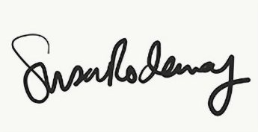
Susan Rodaway
Town Clerk and RFO
Pontarddulais Town Council
20/06/2025

