`
CYNGOR TREF PONTARDDULAIS TOWN COUNCIL


Clerk: Susan Rodaway
45 St Teilo Street
Pontardulais
SWANSEA
SA4 8SY

Tel No: (01792) 803783
Mobile: 07939 592168

Clerc: Susan Rodaway
45 Stryd Sant Teilo
Pontarddulais
ABERTAWE
SA4 8SY

Rhif ffôn: (01792) 803783
Ffôn symudol: 07939 592168

Email/Ebost: clerk@pontarddulaistowncouncil.gov.uk
Website/Gwefan: www.pontarddulaistowncouncil.gov.uk

Correspondence is welcomed in English or Welsh / Croesewir gohebiaeth yn Gymraeg neu’n Saesneg
Dear Member

You are hereby summoned to attend the Extraordinary Council Meeting, of Pontarddulais Town Council in the Council Chamber/Room 1, Mechanics Institute, 45 St Teilo Street, at 7pm on Thursday 16th July 2026.
If you wish to attend the meeting remotely, please contact the Clerk at clerk@pontarddulaistowncouncil.gov.uk for the Teams link
by Midday on Wednesday 15th July 2026
Council meetings are recorded by the Town Clerk for minute-taking purposes and are deleted once the minutes are agreed. Recording by any other means/persons is prohibited.

Apologies for Absence
Disclosures of Personal and Prejudicial interests in accordance with the Council’s Code of Conduct.
Questions from the public relating to items on the agenda. (limited to 15 minutes)

EXTRAORDINARY MEETING AGENDA

- To discuss and consider funding request from County Councillors for new play area in Dantwyn Park.
- To consider amended logo designs and agree a way forward
- To rescind the following resolution made at the Annual Meeting, 19th May 2026 following request from 6 Councillors: “2026-27 AM8 To agree the planned time and date of ordinary meetings of the Council up to and including the next annual meeting of the Council.”
- To agree to return to Ordinary Council Meetings taking place on the last Thursday of the month.
It is proposed under the Public Bodies (Admission to Meetings) Act 1960, the public and representatives of the press and broadcast media be excluded from the meeting during the consideration of the following item(s) of business as publicity would be prejudicial to the public interest because of the confidential nature of the business to be transacted.
- To consider Complaint to Council and agree a way forward.

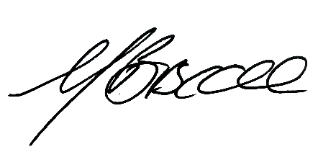

Mayor
Pontarddulais Town Council
10/07/2026

