CYNGOR TREF PONTARDDULAIS TOWN COUNCIL

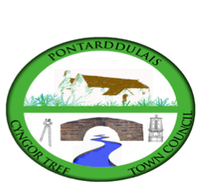
Clerk: Susan Rodaway
45 St Teilo Street
Pontardulais
SWANSEA
SA4 8SY

Tel No: 01792 803783
Mobile: 07939 592168

Clerc: Susan Rodaway
45 Stryd Sant Teilo
Pontarddulais
ABERTAWE
SA4 8SY

Rhif ffôn: 01792 803783
Ffôn Symudol: 07939 592168

Email/Ebost: clerk@pontarddulaistowncouncil.gov.uk
Website/Gwefan: www.pontarddulaistowncouncil.gov.uk

Correspondence is welcomed in English or Welsh / Croesewir gohebiaeth yn Gymraeg neu’n Saesneg.
Dear Member

You are hereby summoned to attend the Policy, Compliance and Finance Committee Meeting, of Pontarddulais Town Council in the Council Chamber/Room 1, Mechanics Institute, 45 St Teilo Street, Pontarddulais on Wednesday 15th January 2025 at 7pm

If you wish to attend the meeting remotely, please contact the Clerk at clerk@pontarddulaistowncouncil.gov.uk for the Teams link
by Tuesday 14th January 2025.

Council meetings are recorded for minute taking purposes and are deleted once minutes are agreed.

Apologies for Absence
Declarations of Interest
Questions from the public relating to items on the agenda. (limited to 15 minutes)

Policy, Compliance and Finance Agenda

- To appoint a Vice Chair of the committee
- To receive update on Food Poverty/Warm Space funding and agree any actions
- To receive update on Heritage Grant and agree a way forward
- To note application to MyG Grant fund.
- To consider creating an Environment Committee or adding “Environment” to an existing committee for recommendation to Full Council.
- To discuss and agree Admin budget 2025/26 for recommendation to Full Council.

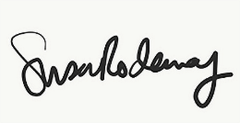
Susan Rodaway
Town Clerk
10/01/2025

