
Clerk: Susan Rodaway
45 St Teilo Street
Pontardulais
SWANSEA
SA4 8SY

Tel No: (01792) 803783
Mobile: 07939 592168

Clerc: Susan Rodaway
45 Stryd Sant Teilo
Pontarddulais
ABERTAWE
SA4 8SY

Rhif ffôn: (01792) 803783
Ffôn symudol: 07939 592168
CYNGOR TREF PONTARDDULAIS TOWN COUNCIL

Email/Ebost: clerk@pontarddulaistowncouncil.gov.uk
Website/Gwefan: www.pontarddulaistowncouncil.gov.uk

Correspondence is welcomed in English or Welsh / Croesewir gohebiaeth yn Gymraeg neu’n Saesneg
Dear Member

You are hereby summoned to attend the Policy, Compliance and Finance Committee Meeting, of Pontarddulais Town Council in the Council Chamber/Room 1, Mechanics Institute, 45 St Teilo Street, Pontarddulais on Tuesday 4th November 2025 at 7.30pm

If you wish to attend the meeting remotely, please contact the Clerk at clerk@pontarddulaistowncouncil.gov.uk for the Teams link
by Monday 3rd November 2025

Council meetings are recorded for minute taking purposes and are deleted once minutes are agreed.

Policy, Compliance and Finance Committee Meeting Agenda

- To Discuss and agree a way forward to create a Youth Town Council
- To discuss update to Social Media Policy and agree a way forward
- To discuss options and agree on a new Council mobile phone as agreed by Full Council
- To complete random audit of September and October payments
- To note October Closing balances
- To note end of Qtr. 2 closing balances 2025/26
- To discuss projected spending for 2025/26 and agree any virements
- To note current reserve levels
- To begin budget setting for Admin Budget 2026/27

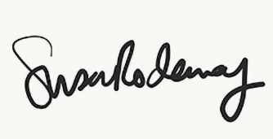

Susan Rodaway
Town Clerk
30/10/2025

