
Clerk: Susan Rodaway
45 St Teilo Street
Pontardulais
SWANSEA
SA4 8SY

Tel No: (01792) 803783
Mobile: 07939 592168

Clerc: Susan Rodaway
45 Stryd Sant Teilo
Pontarddulais
ABERTAWE
SA4 8SY

Rhif ffôn: (01792) 803783
Ffôn symudol: 07939 592168
CYNGOR TREF PONTARDDULAIS TOWN COUNCIL

Email/Ebost: clerk@pontarddulaistowncouncil.gov.uk
Website/Gwefan: www.pontarddulaistowncouncil.gov.uk

Correspondence is welcomed in English or Welsh / Croesewir gohebiaeth yn Gymraeg neu’n Saesneg
Dear Member

You are hereby summoned to attend the Policy, Compliance and Finance Committee Meeting, of Pontarddulais Town Council in the Council Chamber/Room 1, Mechanics Institute, 45 St Teilo Street, Pontarddulais on Thursday 19th February 2026 at 7.30pm

If you wish to attend the meeting remotely, please contact the Clerk at clerk@pontarddulaistowncouncil.gov.uk for the Teams link
by Midday on Wednesday 18th February 2026

Council meetings are recorded for minute taking purposes and are deleted once minutes are agreed.

Agenda

- To complete random audit of November and December payments
- To complete random audit of January payments
- To note January 2026 closing balances
- To agree February payments made and anticipated for recommendation to Full Council
- To discuss issues with current Finance software and alternative options available and agree a way forward for recommendation to Full Council
- To discuss a potential increase in hire charges for the Mechanics Institute from 1st April 2026 for recommendation to Full Council
- To agree membership of community grant-awarding panel for 2025/26
- To discuss community response to the proposed vision for the Town Council and agree a way forward for recommendation to Full Council

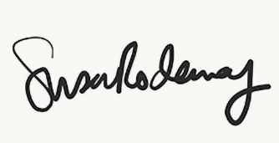

Susan Rodaway
Town Clerk
13/02/2026

