CYNGOR TREF PONTARDDULAIS TOWN COUNCIL


Clerk: Susan Rodaway
45 St Teilo Street
Pontardulais
SWANSEA
SA4 8SY

Tel No: (01792) 803783
Mobile: 07939 592168

Clerc: Susan Rodaway
45 Stryd Sant Teilo
Pontarddulais
ABERTAWE
SA4 8SY

Rhif ffôn: (01792) 803783
Ffôn symudol: 07939 592168

Email/Ebost: clerk@pontarddulaistowncouncil.gov.uk
Website/Gwefan: www.pontarddulaistowncouncil.gov.uk

Correspondence is welcomed in English or Welsh / Croesewir gohebiaeth yn Gymraeg neu’n Saesneg
Dear Member

You are hereby summoned to attend the Special Events Committee Meeting, of Pontarddulais Town Council in the Council Chamber/Room 1, Mechanics Institute, 45 St Teilo Street, Pontarddulais on Thursday 19th January 2026 at 7.00pm

If you wish to attend the meeting remotely, please contact the Clerk at clerk@pontarddulaistowncouncil.gov.uk for the Teams link
by Wednesday 18th January 2026 at 12pm.

Council meetings are recorded for minute-taking purposes and are deleted once minutes are agreed.

Apologies for Absence
Declarations of Interest
Questions from the public relating to items on the agenda. (limited to 15 minutes)

AGENDA

- To discuss and agree Easter Events 2026
- To discuss and agree Summer Fair arrangements going forward

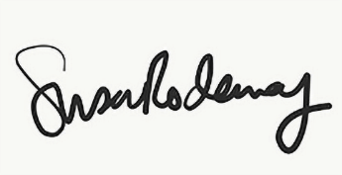
Susan Rodaway
Town Clerk and RFO
Pontarddulais Town Council
13/03/2026

