CYNGOR TREF PONTARDDULAIS TOWN COUNCIL

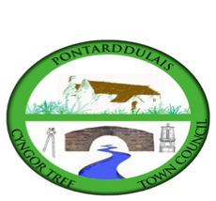
Clerk: Susan Rodaway
45 St Teilo Street
Pontardulais
SWANSEA
SA4 8SY

Tel No: (01792) 803783
Mobile: 07939 592168

Clerc: Susan Rodaway
45 Stryd Sant Teilo
Pontarddulais
ABERTAWE
SA4 8SY

Rhif ffôn: (01792) 803783
Ffôn symudol: 07939 592168

Email/Ebost: clerk@pontarddulaistowncouncil.gov.uk
Website/Gwefan: www.pontarddulaistowncouncil.gov.uk

Correspondence is welcomed in English or Welsh / Croesewir gohebiaeth yn Gymraeg neu’n Saesneg
Dear Member

You are hereby summoned to attend the Special Events Committee Meeting, of Pontarddulais Town Council in the Council Chamber/Room 1, Mechanics Institute, 45 St Teilo Street, Pontarddulais on Thursday 23rd April 2026 at 7.30 pm

If you wish to attend the meeting remotely, please contact the Clerk at clerk@pontarddulaistowncouncil.gov.uk for the Teams link
by Wednesday 22nd April 2026 at 12pm.

Council meetings are recorded for minute-taking purposes and are deleted once minutes are agreed.

Apologies for Absence
Declarations of Interest
Questions from the public relating to items on the agenda. (limited to 15 minutes)

AGENDA

- To discuss Spring 2026 event including learning outcomes
- To discuss and agree to move Summer event to the last Saturday in July
- To agree Summer Event Working group set-up
- To consider recommending the appointment of an Events and Community Engagement Officer to Full Council
- To discuss proposal from a member of the public to support a community theatre company and agree a way forward.

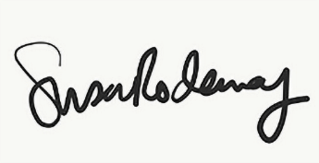
Susan Rodaway
Town Clerk and RFO
Pontarddulais Town Council
16/04/2026

