CYNGOR TREF PONTARDDULAIS TOWN COUNCIL


Clerk: Susan Rodaway
45 St Teilo Street
Pontardulais
SWANSEA
SA4 8SY

Tel No: (01792) 803783
Mobile: 07939 592168

Clerc: Susan Rodaway
45 Stryd Sant Teilo
Pontarddulais
ABERTAWE
SA4 8SY

Rhif ffôn: (01792) 803783
Ffôn symudol: 07939 592168

Email/Ebost: clerk@pontarddulaistowncouncil.gov.uk
Website/Gwefan: www.pontarddulaistowncouncil.gov.uk

Correspondence is welcomed in English or Welsh / Croesewir gohebiaeth yn Gymraeg neu’n Saesneg
Dear Member

You are hereby summoned to attend the Special Events Committee Meeting, of Pontarddulais Town Council in the Council Chamber/Room 1, Mechanics Institute, 45 St Teilo Street, Pontarddulais on Wednesday 29th July 2026 at 7.00 pm

If you wish to attend the meeting remotely, please contact the Clerk at clerk@pontarddulaistowncouncil.gov.uk for the Teams link
by Tuesday 28th July 2026 at 12pm.

Council meetings are recorded for minute-taking purposes and are deleted once minutes are agreed.

Apologies for Absence
Declarations of Interest
Questions from the public relating to items on the agenda. (limited to 15 minutes)

AGENDA

- To elect a Vice Chair
- To discuss and agree to vire monies within Special Events budget to fund cinema equipment expenditure not included in grant funding.
- Update on Summer holiday activites supported by Swansea Council Wellbeing Grant fund.
- To agree discuss progress made by the Working Group on the Summer Fair and agree next steps.
- To discuss printing costs for Summer Quiz and agree a way forward.

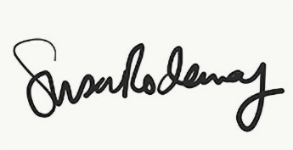
Susan Rodaway
Town Clerk and RFO
Pontarddulais Town Council
24/07/2026

