CYNGOR TREF PONTARDDULAIS TOWN COUNCIL

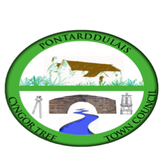
Clerk: Susan Rodaway
45 St Teilo Street
Pontardulais
SWANSEA
SA4 8SY

Tel No: 01792 803783
Mobile: 07939 592168

Clerc: Susan Rodaway
45 Stryd Sant Teilo
Pontarddulais
ABERTAWE
SA4 8SY

Rhif ffôn: 01792 803783
Ffôn Symudol: 07939 592168

Email/Ebost: clerk@pontarddulaistowncouncil.gov.uk
Website/Gwefan: www.pontarddulaistowncouncil.gov.uk

Correspondence is welcomed in English or Welsh / Croesewir gohebiaeth yn Gymraeg neu’n Saesneg.
Dear Member

You are hereby summoned to attend the Estates and Environment Committee Meeting, of Pontarddulais Town Council in the Council Chamber/Room 1, Mechanics Institute, 45 St Teilo Street, Pontarddulais on Monday 1st September 2025 at 8pm

If you wish to attend the meeting remotely, please contact the Clerk at clerk@pontarddulaistowncouncil.gov.uk for the Teams link
by Monday 1st September 2025 at 12pm.

Council meetings are recorded for minute taking purposes and are deleted once minutes are agreed.

Apologies for Absence
Declarations of Interest
Questions from the public relating to items on the agenda. (limited to 15 minutes)

Estates Agenda

Estates and Environment Committee joins Special Events Committee for the first agenda item.

- To discuss options for Christmas trees and lighting and agree a way forward.

Special Events Committee meeting closes at this point.

- To elect a Vice Chair
- To note booking of Fire Risk Assessment
- To note Boiler Servicing
- To agree to purchase and install a Systemizer for the gents toilet to reduce water usage.
- To note installation of replacement radiator in toilet external area.
- To discuss and agree wall covering for kitchen installation following removal of old kitchen revealing poor wall condition.
- To agree maintenance/replacement of hall lighting for energy-efficient options
- To agree purchase of paint and materials to update the front boundary wall and pillars.
- Update on Damp survey and agree a way forward.
- Discuss Cenotaph area maintenance and biodiversity improvements and agree a way forward.
- To discuss improvements and upgrade to existing CCTV system and new internal and external cameras.

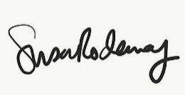
Susan Rodaway
Town Clerk
27/09/2025

