CYNGOR TREF PONTARDDULAIS TOWN COUNCIL COUNCIL

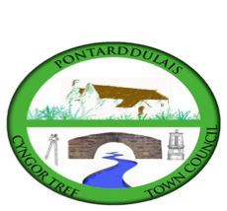
Clerk: Susan Rodaway
45 St Teilo Street
Pontardulais
SWANSEA
SA4 8SY

Tel No: 01792 803783
Mobile: 07939 592168

Clerc: Susan Rodaway
45 Stryd Sant Teilo
Pontarddulais
ABERTAWE
SA4 8SY

Rhif ffôn: 01792 803783
Ffôn Symudol: 07939 592168

Email/Ebost: clerk@pontarddulaistowncouncil.gov.uk
Website/Gwefan: www.pontarddulaistowncouncil.gov.uk

Correspondence is welcomed in English or Welsh / Croesewir gohebiaeth yn Gymraeg neu’n Saesneg.
Dear Member

You are hereby summoned to attend the Estates and Environment Committee Meeting, of Pontarddulais Town Council in the Council Chamber/Room 1, Mechanics Institute, 45 St Teilo Street, Pontarddulais on Thursday 6th September 2025 at 7pm

If you wish to attend the meeting remotely, please contact the Clerk at clerk@pontarddulaistowncouncil.gov.uk for the Teams link
by Wednesday 5th November 2025 at 12pm.

Council meetings are recorded for minute taking purposes and are deleted once minutes are agreed. Recording of the meeting by any other means is prohibited.

Apologies for Absence
Declarations of Interest
Questions from the public relating to items on the agenda. (limited to 15 minutes)

Estates Agenda

- To discuss options for Christmas trees and lighting and agree a way forward.
- To note outcome of Fire Risk Assessment (FRA)
- To agree an action plan to address items raised in FRA
- Update on light survey for Mechanics Institute
- To discuss and agree repair and maintenance priorities for Mechanics Institute to be paid for by MyG capital grant and agree a way forward.
- To discuss Local Places for Nature Officer Biodiversity Report and agree a way forward.

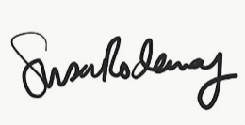
Susan Rodaway
Town Clerk
31/10/2025

