CYNGOR TREF PONTARDDULAIS TOWN COUNCIL COUNCIL

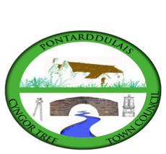
Clerk: Susan Rodaway
45 St Teilo Street
Pontardulais
SWANSEA
SA4 8SY

Tel No: 01792 803783
Mobile: 07939 592168

Clerc: Susan Rodaway
45 Stryd Sant Teilo
Pontarddulais
ABERTAWE
SA4 8SY

Rhif ffôn: 01792 803783
Ffôn Symudol: 07939 592168

Email/Ebost: clerk@pontarddulaistowncouncil.gov.uk
Website/Gwefan: www.pontarddulaistowncouncil.gov.uk

Correspondence is welcomed in English or Welsh / Croesewir gohebiaeth yn Gymraeg neu’n Saesneg.
Dear Member

You are hereby summoned to attend the Estates and Environment Committee Meeting, of Pontarddulais Town Council in the Council Chamber/Room 1, Mechanics Institute, 45 St Teilo Street, Pontarddulais on Tuesday 13th January 2026 at 7pm.

If you wish to attend the meeting remotely, please contact the Clerk at clerk@pontarddulaistowncouncil.gov.uk for the Teams link
By Midday on Monday 12th January 2026

Council meetings are recorded for minute-taking purposes and are deleted once minutes are agreed. Recording of the meeting by any other means is prohibited.

Apologies for Absence
Declarations of Interest
Questions from the public relating to items on the agenda. (limited to 15 minutes)

Agenda

- Update on the Fire Risk Assessment (FRA) actions taken, and in progress
- To agree to get quotes for external fencing bordering the pavement of the Mechanics Institute.
- To consider expected spend for 2025/26 and agree any funds for ring-fencing into 2026/27
- To agree committee draft budget for 2026/27

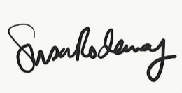
Susan Rodaway
Town Clerk
07/01//2026

