CYNGOR TREF PONTARDDULAIS TOWN COUNCIL COUNCIL

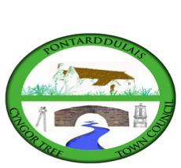
Clerk: Susan Rodaway
45 St Teilo Street
Pontardulais
SWANSEA
SA4 8SY

Tel No: 01792 803783
Mobile: 07939 592168

Clerc: Susan Rodaway
45 Stryd Sant Teilo
Pontarddulais
ABERTAWE
SA4 8SY

Rhif ffôn: 01792 803783
Ffôn Symudol: 07939 592168

Email/Ebost: clerk@pontarddulaistowncouncil.gov.uk
Website/Gwefan: www.pontarddulaistowncouncil.gov.uk

Correspondence is welcomed in English or Welsh / Croesewir gohebiaeth yn Gymraeg neu’n Saesneg.
Dear Member

You are hereby summoned to attend the Estates and Environment Committee Meeting, of Pontarddulais Town Council in the Council Chamber/Room 1, Mechanics Institute, 45 St Teilo Street, Pontarddulais on Wednesday 11th February 2026 at 7pm.

If you wish to attend the meeting remotely, please contact the Clerk at clerk@pontarddulaistowncouncil.gov.uk for the Teams link
By Midday on Tuesday 10th February 2026

Council meetings are recorded for minute-taking purposes and are deleted once minutes are agreed. Recording of the meeting by any other means is prohibited.

Apologies for Absence
Declarations of Interest
Questions from the public relating to items on the agenda. (limited to 15 minutes)

Agenda

- To elect a Vice Chair until the Annual Meeting
- Update on Kitchen refurbishment
- To receive quotes for structural survey for Mechanics Institute and agree contractor.
- To receive quotes for balcony repair and new railing and agree contractor
- To receive quotes for wall repair at Cenotaph and agree contractor
- To receive quotes for ground levelling at cenotaph and agree contractor
- To discuss and agree biodiversity development at cenotaph with current ground maintenance contractor.

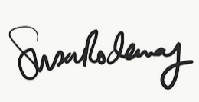
Susan Rodaway
Town Clerk
06/02/2026

