CYNGOR TREF PONTARDDULAIS TOWN COUNCIL COUNCIL

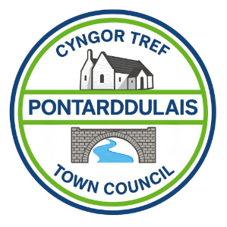
Clerk: Susan Rodaway
45 St Teilo Street
Pontardulais
SWANSEA
SA4 8SY

Tel No: 01792 803783
Mobile: 07939 592168

Clerc: Susan Rodaway
45 Stryd Sant Teilo
Pontarddulais
ABERTAWE
SA4 8SY

Rhif ffôn: 01792 803783
Ffôn Symudol: 07939 592168

Email/Ebost: clerk@pontarddulaistowncouncil.gov.uk
Website/Gwefan: www.pontarddulaistowncouncil.gov.uk

Correspondence is welcomed in English or Welsh / Croesewir gohebiaeth yn Gymraeg neu’n Saesneg.
Dear Member
You are hereby summoned to attend the Estates and Environment Committee Meeting, of Pontarddulais Town Council in the Council Chamber/Room 1, Mechanics Institute, 45 St Teilo Street, Pontarddulais on Thursday 24th September 2026 at 7pm.

If you wish to attend the meeting remotely, please contact the Clerk at clerk@pontarddulaistowncouncil.gov.uk for the Teams link
By Midday on Wednesday 23rd September 2026

Council meetings are recorded for minute-taking purposes and are deleted once minutes are agreed. Recording of the meeting by any other means is prohibited.

Apologies for Absence
Declarations of Interest
Questions from the public relating to items on the agenda. (limited to 15 minutes)

Agenda

- Elect a Vice Chair
- Receive condition survey report for Mechanics Institute.
- To discuss request to full council for additional funding for repairs and maintenance of Mechanics Institute as set out in fire risk assessment and condition survey, and agree a way forward.
- To agree to load bearing test for balcony.
- To agree to a structural survey of the external fire escape
- To agree contractor to supply and install external fire doors at the Mechanics Institute.
- To agree emergency lighting works and contractor.
- To agree to appoint a contractor to complete the painting at the front of the Mechanics Institute
- To discuss and agree to apply for grant funding for roof maintenance and solar panels at the Mechanics Institute.
- To discuss and agree purchase of planters and native planting for the front of the Mechanics Institute

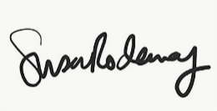
Susan Rodaway
Town Clerk
06/02/2026

