CYNGOR TREF PONTARDDULAIS TOWN COUNCIL

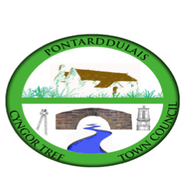
Clerk: Susan Rodaway
45 St Teilo Street
Pontardulais
SWANSEA
SA4 8SY

Tel No: 01792 803783
Mobile: 07939 592168

Clerc: Susan Rodaway
45 Stryd Sant Teilo
Pontarddulais
ABERTAWE
SA4 8SY

Rhif ffôn: 01792 803783
Ffôn Symudol: 07939 592168

Email/Ebost: clerk@pontarddulaistowncouncil.gov.uk
Website/Gwefan: www.pontarddulaistowncouncil.gov.uk

Correspondence is welcomed in English or Welsh / Croesewir gohebiaeth yn Gymraeg neu’n Saesneg.
Dear Member

You are hereby summoned to attend the HR and Training Committee Meeting, of Pontarddulais Town Council in the Council Chamber/Room 1, Mechanics Institute, 45 St Teilo Street, Pontarddulais on Thursday 16th January 2025 at 7pm

If you wish to attend the meeting remotely, please contact the Clerk at: clerk@pontarddulaistowncouncil.gov.uk for the Teams link by Tuesday 14th January 2025.

Council meetings are recorded for minute taking purposes and are deleted once minutes are agreed.

Apologies for Absence
Declarations of Interest
Questions from the public relating to items on the agenda. (limited to 15 minutes)

HR and Training Agenda

- Motion to exclude public and press for items 2 and 3.
- To discuss and agree recommendation to Full Council for employee to join NALC/NJC Salary Scale.
- To discuss and agree recommendation to Full Council for increase in hours and salary spine point for employee.
- Review of HR Policies
- To review the Council training plan for Councillors and Employees and agree any changes.
- To agree to make representations to Full Council to appoint a Community Engagement and Development Officer subject to funding applications.
- To note application to Mynydd y Gwair Grant fund.
- To discuss and agree HR and training budget 2025/26 for recommendation to Full Council.

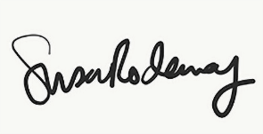
Susan Rodaway
Town Clerk

