CYNGOR TREF PONTARDDULAIS TOWN COUNCIL

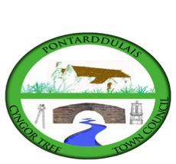
Clerk: Susan Rodaway
45 St Teilo Street
Pontardulais
SWANSEA
SA4 8SY

Tel No: 01792 803783
Mobile: 07939 592168

Clerc: Susan Rodaway
45 Stryd Sant Teilo
Pontarddulais
ABERTAWE
SA4 8SY

Rhif ffôn: 01792 803783
Ffôn Symudol: 07939 592168

Email/Ebost: clerk@pontarddulaistowncouncil.gov.uk
Website/Gwefan: www.pontarddulaistowncouncil.gov.uk

Correspondence is welcomed in English or Welsh / Croesewir gohebiaeth yn Gymraeg neu’n Saesneg.
Dear Member, you are hereby summoned to attend the HR and Training Committee Meeting, of Pontarddulais Town Council in the Council Chamber/Room 1, Mechanics Institute, 45 St Teilo Street, Pontarddulais on Tuesday 17th February 2026 at 7pm
If you wish to attend the meeting remotely, please contact the Clerk at: clerk@pontarddulaistowncouncil.gov.uk for the Teams link Monday 16th February 2026
Council meetings are recorded for minute taking purposes and are deleted once minutes are agreed. Recording of the meeting by any other means is prohibited.

Apologies for Absence
Declarations of Interest
Questions from the public relating to items on the agenda. (limited to 15 minutes)
Agenda

- To discuss the Civility and Respect Pledge and agree a way forward

- To discuss and agree Council Civility and Respect training proposal from Council Culture

- To discuss training plan update

It is proposed under the Public Bodies (Admission to Meetings) Act 1960, the public and representatives of the press and broadcast media be excluded from the meeting during the consideration of item 10 as publicity would be prejudicial to the public interest because of the confidential nature of the business to be transacted

- To receive conclusions from employee role evaluation.
- To discuss and agree a change of title for employee (as recommended in role evaluation exercise) and agree to recommend the new title to Full Council for acceptance.
- To discuss and agree a new Spinal Column Point (SCP) for the role (as recommended in role evaluation exercise) and agree to recommend to Full Council for acceptance.
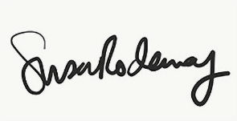

Susan Rodaway
Town Clerk 11/02/2026

