CYNGOR TREF PONTARDDULAIS TOWN COUNCIL

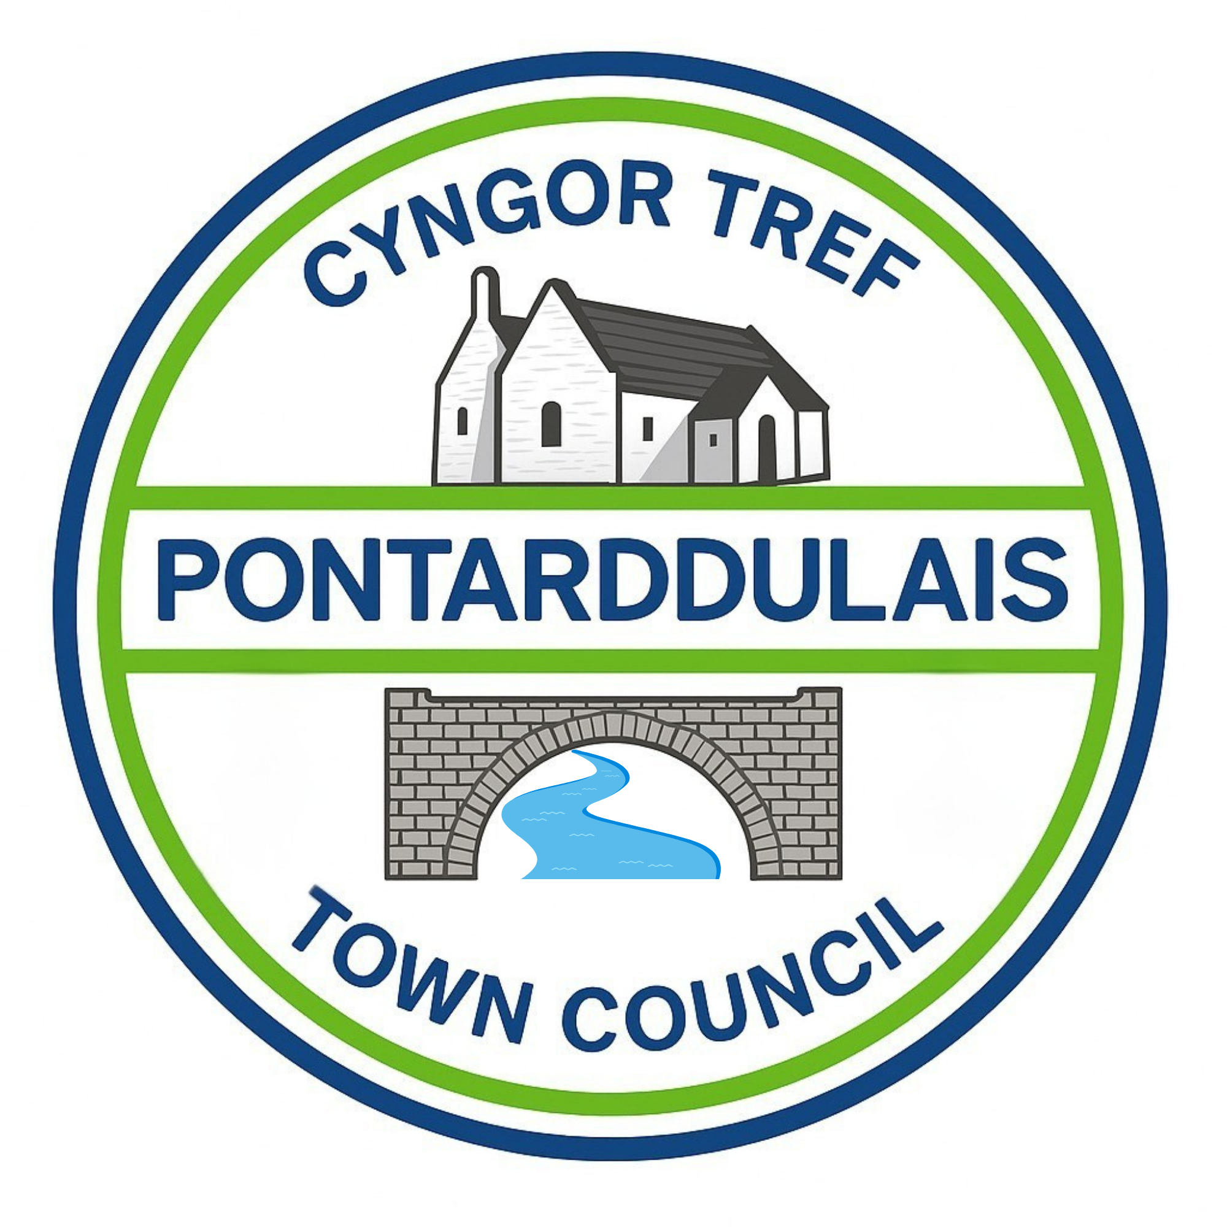
Clerk: Susan Rodaway
45 St Teilo Street
Pontardulais
SWANSEA
SA4 8SY

Tel No: 01792 803783
Mobile: 07939 592168

Clerc: Susan Rodaway
45 Stryd Sant Teilo
Pontarddulais
ABERTAWE
SA4 8SY

Rhif ffôn: 01792 803783
Ffôn Symudol: 07939 592168

Email/Ebost: clerk@pontarddulaistowncouncil.gov.uk
Website/Gwefan: www.pontarddulaistowncouncil.gov.uk

Correspondence is welcomed in English or Welsh / Croesewir gohebiaeth yn Gymraeg neu’n Saesneg.
Dear Member,
You are hereby summoned to attend the HR and Training Committee Meeting, of Pontarddulais Town Council in the Council Chamber/Room 1, Mechanics Institute, 45 St Teilo Street, Pontarddulais on Tuesday 13th October 2026 at 7.45pm
If you wish to attend the meeting remotely, please contact the Clerk at: clerk@pontarddulaistowncouncil.gov.uk for the Teams link Monday 12th October 2026
Council meetings are recorded for minute taking purposes and are deleted once minutes are agreed. Recording of the meeting by any other means is prohibited.

Apologies for Absence
Declarations of Interest
Questions from the public relating to items on the agenda. (limited to 15 minutes)
Agenda

- To remind all Councillors of their mandatory training requirements, as agreed by the Council.

It is proposed under the Public Bodies (Admission to Meetings) Act 1960, the public and representatives of the press and broadcast media be excluded from the meeting during consideration of the following item(s) of business as publicity would be prejudicial to the public interest because of the confidential nature of the business to be transacted

- To receive conclusions from employee role evaluation.
- To discuss and agree a change of title for employee (as recommended in role evaluation exercise) and agree to recommend the new title to Full Council for acceptance.
- To discuss and agree a new Spinal Column Point (SCP) for the role (as recommended in role evaluation exercise) and agree to recommend to Full Council for acceptance.
- To determine and agree back payment of any salary owed following outcome of item 5 (above), and agree to recommend to Full Council for acceptance.

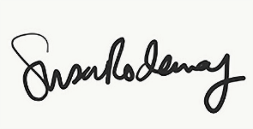
Susan Rodaway
Town Clerk 08/10/2026

