CYNGOR TREF PONTARDDULAIS TOWN COUNCIL
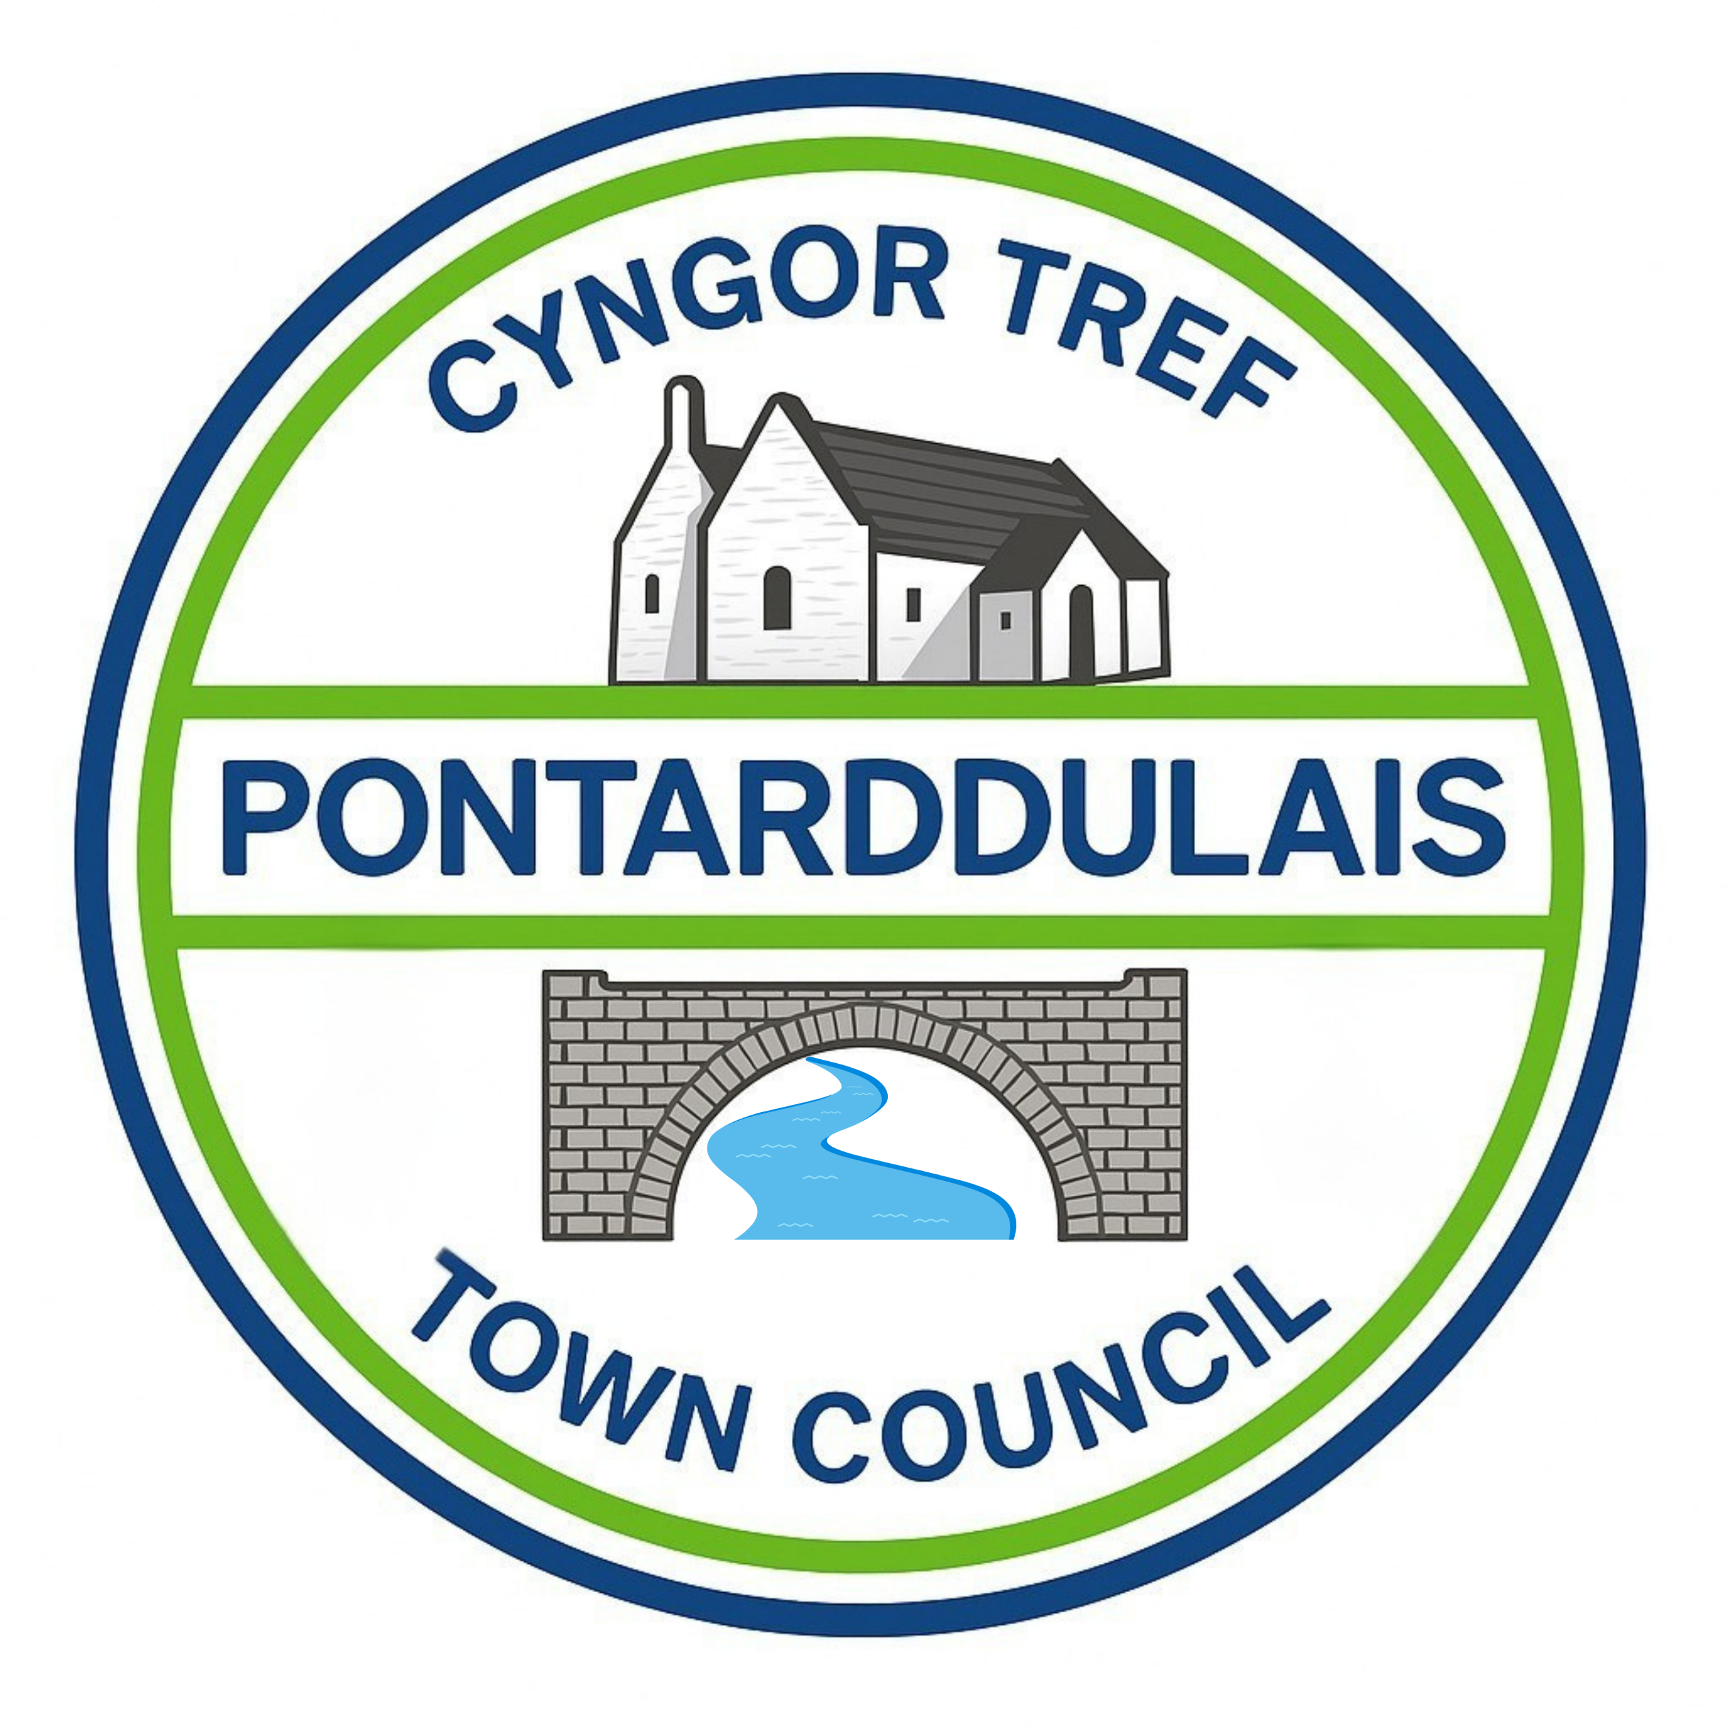
Clerc: Susan Rodaway
45 Stryd Sant Teilo
Pontarddulais
ABERTAWE
SA4 8SY

Rhif ffôn: (01792) 803783
Ffôn symudol: 07939 592168
Clerk: Susan Rodaway
45 St Teilo Street
Pontardulais
SWANSEA
SA4 8SY

Tel No: (01792) 803783
Mobile: 07939 592168

Email/Ebost: clerk@pontarddulaistowncouncil.gov.uk
Website/Gwefan: www.pontarddulaistowncouncil.gov.uk

Correspondence is welcomed in English or Welsh / Croesewir gohebiaeth yn Gymraeg neu’n Saesneg
Dear Member
You are hereby summoned to attend the Planning Committee Meeting, of Pontarddulais Town Council on Tuesday 18th August 2026 at 7pm.

If you wish to attend the meeting remotely, please contact the Clerk at clerk@pontarddulaistowncouncil.gov.uk for the Teams link
By Midday on Monday 17th August 2026.

Council meetings are recorded for minute-taking purposes and are deleted once minutes are agreed.
Apologies for Absence
Declarations of Interest
Questions from the public relating to items on the agenda. (limited to 15 minutes)

AGENDA
- 2026/1118/FUL
Proposed subdivision and part change of use of the former Lloyds Bank premises (Class A2) to an indoor golf simulator facility (Class D2). The development will provide 1 x golf simulator bay for recreational and leisure use, together with waiting area, WC facilities and ancillary storage. An 18 square metre bar is proposed within the existing bank vault, serving alcoholic and non-alcoholic beverages to customers using the facility
Unit 1, 47 St Teilo Street Pontarddulais Swansea SA4 8SY

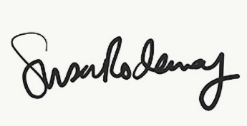
Susan Rodaway
Town Clerk and RFO
Pontarddulais Town Council
13/08/2026

