CYNGOR TREF PONTARDDULAIS TOWN COUNCIL
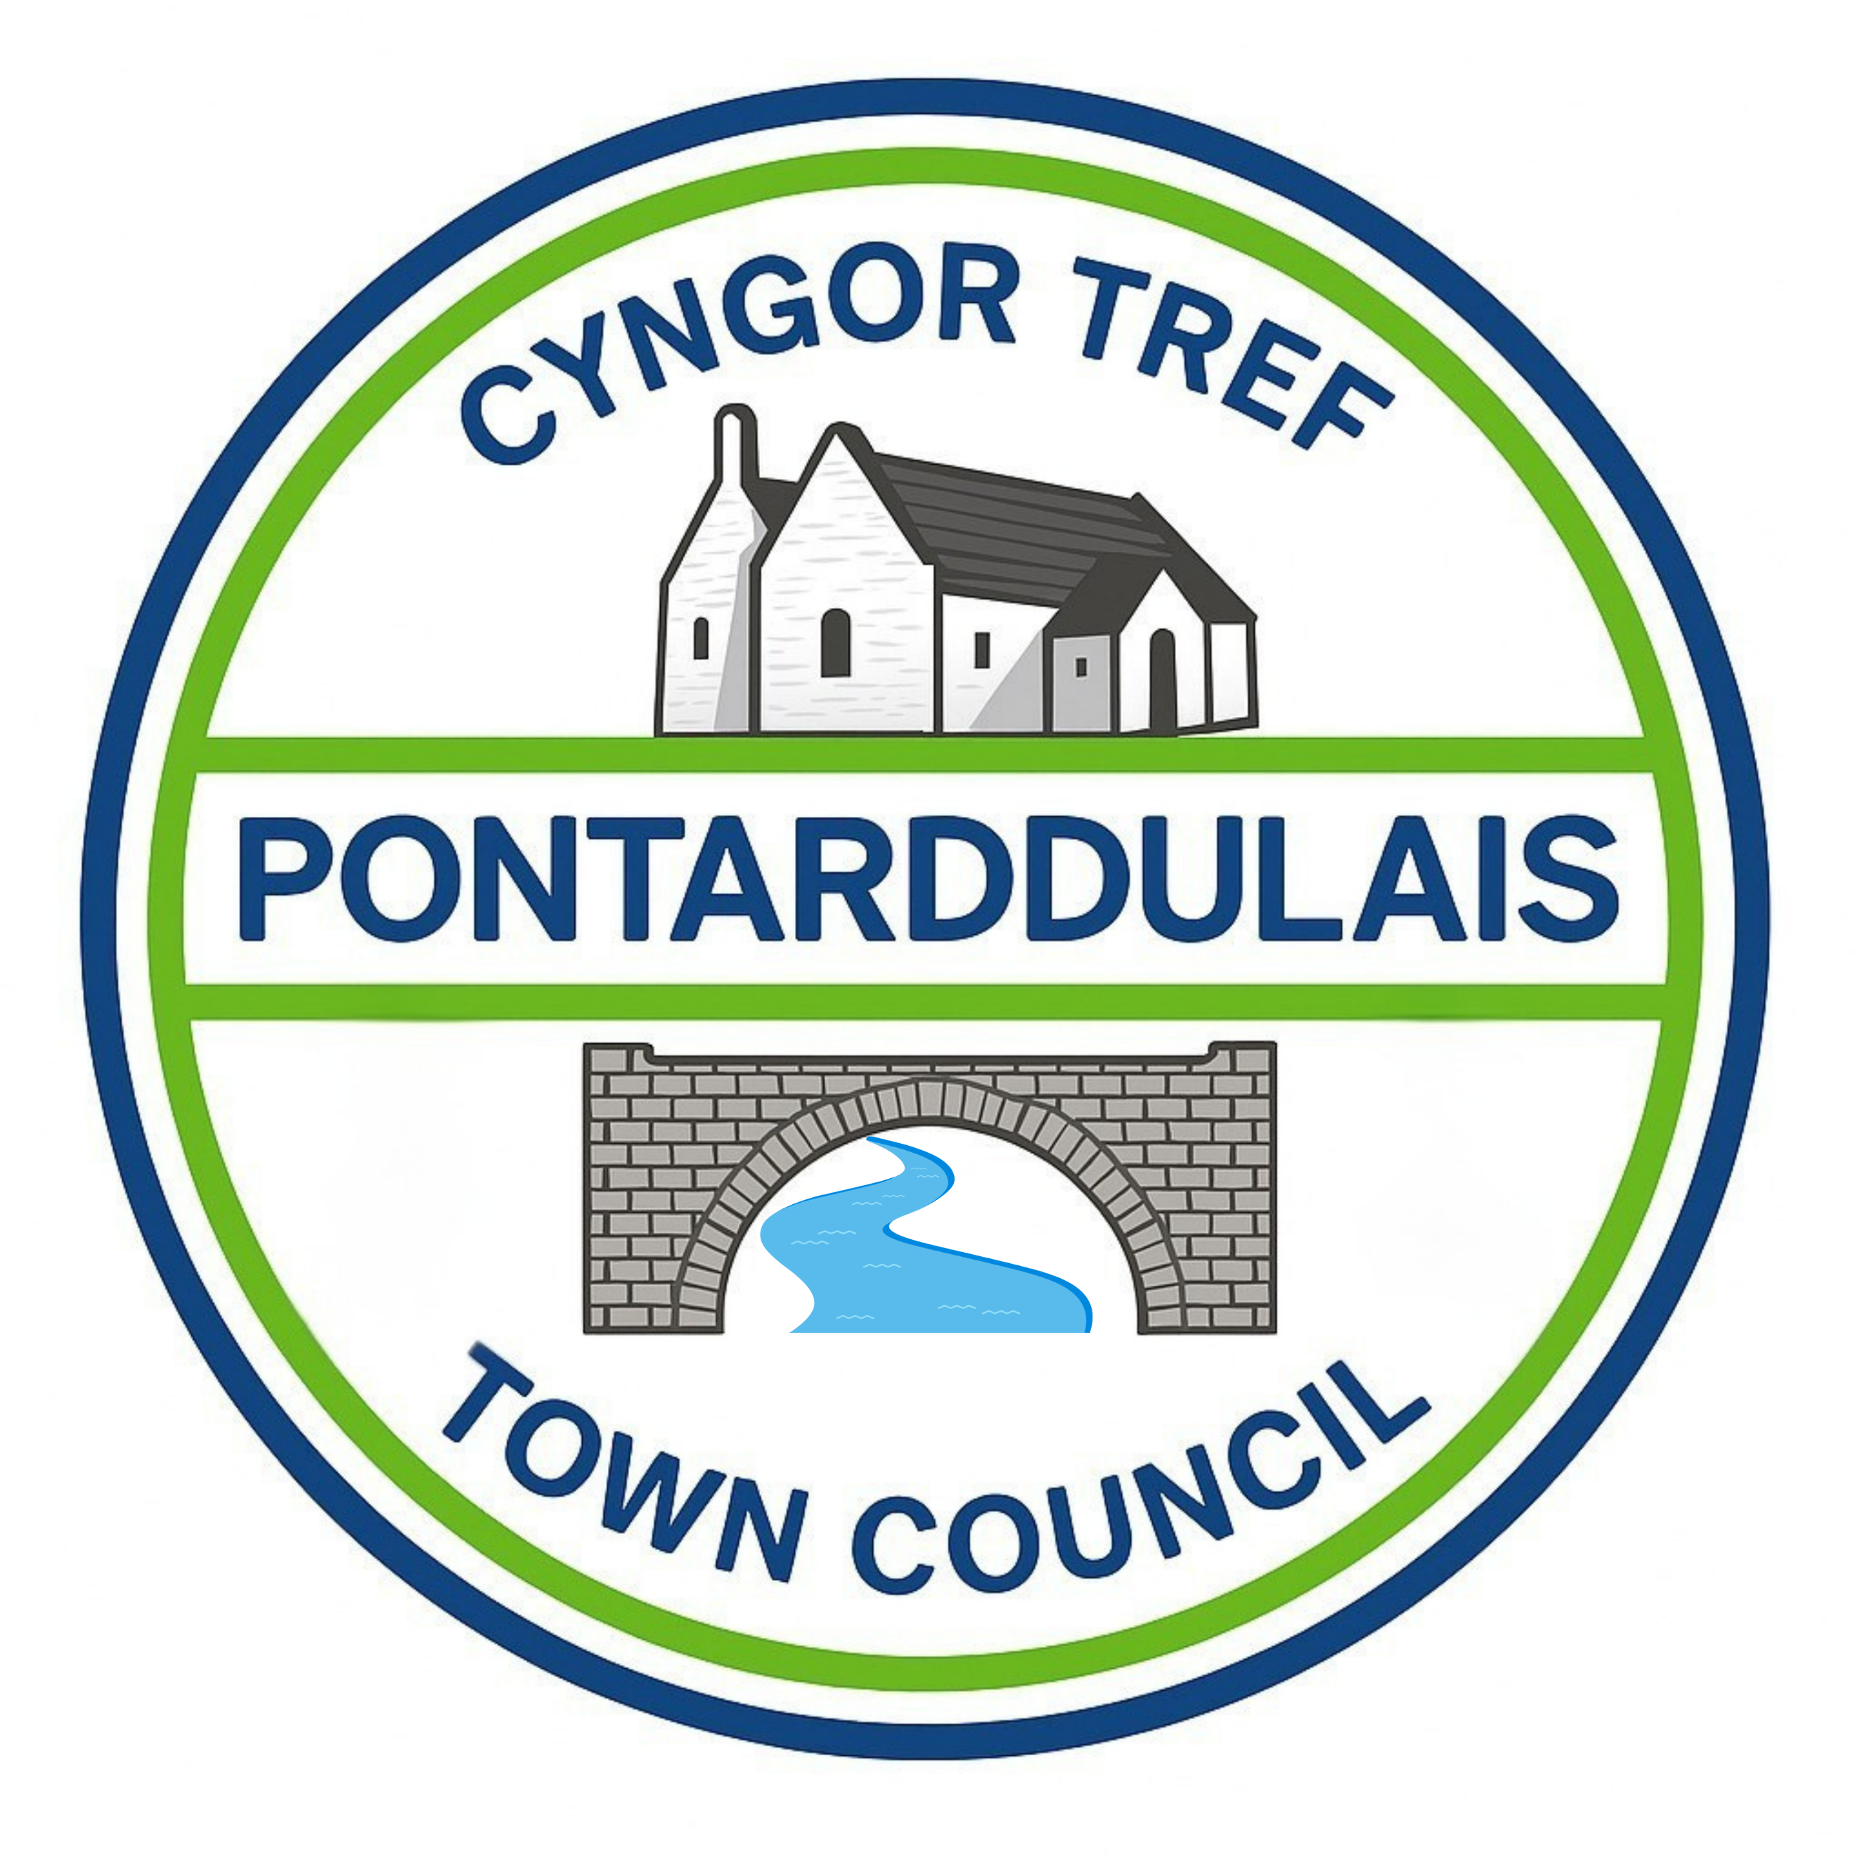
Clerc: Susan Rodaway
45 Stryd Sant Teilo
Pontarddulais
ABERTAWE
SA4 8SY

Rhif ffôn: (01792) 803783
Ffôn symudol: 07939 592168
Clerk: Susan Rodaway
45 St Teilo Street
Pontardulais
SWANSEA
SA4 8SY

Tel No: (01792) 803783
Mobile: 07939 592168

Email/Ebost: clerk@pontarddulaistowncouncil.gov.uk
Website/Gwefan: www.pontarddulaistowncouncil.gov.uk

Correspondence is welcomed in English or Welsh / Croesewir gohebiaeth yn Gymraeg neu’n Saesneg
Dear Member
You are hereby summoned to attend the Planning Committee Meeting, of Pontarddulais Town Council on Tuesday 6th October 2026 at 7 pm.

If you wish to attend the meeting remotely, please contact the Clerk at clerk@pontarddulaistowncouncil.gov.uk for the Teams link
By Midday on Monday 5th October 2026.

Council meetings are recorded for minute-taking purposes and are deleted once minutes are agreed.
Apologies for Absence
Declarations of Interest
Questions from the public relating to items on the agenda. (limited to 15 minutes)

AGENDA
- Gambling Act 2005 - Consultation on proposed amendments to Swansea Council’s Statement of Principles (Gambling Policy) in respect of a proposal to pass a new resolution not to issue casino licences.
Appendix A Review of NCR Sept 26 - Extract from Gambing Policy.docx
Respondent sheet 2026 - English.doc

- Have your say on the future of planning in Wales – Consultation
www.gov.wales/national-development-framework
www.llyw.cymru/fframwaith-datblygu-cenedlaethol

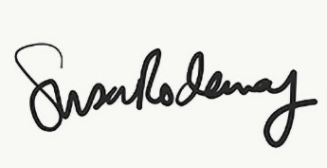
Susan Rodaway
Town Clerk and RFO
Pontarddulais Town Council
25/09/2026

