CYNGOR TREF PONTARDDULAIS TOWN COUNCIL
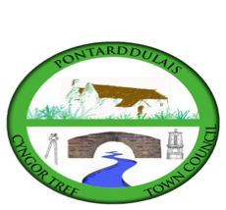
Clerc: Susan Rodaway
45 Stryd Sant Teilo
Pontarddulais
ABERTAWE
SA4 8SY

Rhif ffôn: (01792) 803783
Ffôn symudol: 07939 592168
Clerk: Susan Rodaway
45 St Teilo Street
Pontardulais
SWANSEA
SA4 8SY

Tel No: (01792) 803783
Mobile: 07939 592168

Email/Ebost: clerk@pontarddulaistowncouncil.gov.uk
Website/Gwefan: www.pontarddulaistowncouncil.gov.uk

Correspondence is welcomed in English or Welsh / Croesewir gohebiaeth yn Gymraeg neu’n Saesneg
Dear Member
You are hereby summoned to attend the Planning Committee Meeting, of Pontarddulais Town Council online only on Thursday 15th January 2026 at 7pm.

If you wish to attend the meeting remotely, please contact the Clerk at clerk@pontarddulaistowncouncil.gov.uk for the Teams link
By Midday on Wednesday 14th January 2026.

Council meetings are recorded for minute-taking purposes and are deleted once minutes are agreed.
Apologies for Absence
Declarations of Interest
Questions from the public relating to items on the agenda. (limited to 15 minutes)

AGENDA

- Ref No: 2025/2665/FUL
Rear ground floor extension. Roof extension by raising the ridge and
extension over the rear flat roof extension
21 Twyniago, Pontarddulais, Swansea, SA4 8HX

- Update from Cllr. Kevin Griffiths on the proposed development at Bolgoed Farm.

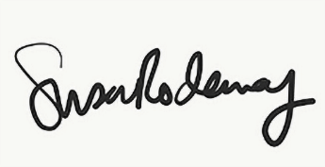
Susan Rodaway
Town Clerk and RFO
Pontarddulais Town Council
08/01/2026

